G
2-3
Compassion Project Reflection

It is inevitable that everyone will experience many challenging times throughout the course of the school year. From big projects, to confusing homework assignments, the year is jam-packed with long, sleepless nights and exhausting days. All our classes are so structured, to the point that I have been taught that my creativity has limits. The monotonous regularity can become extremely stale and lifeless, sucking the life out of my days.

We are judged by our grades, and expected to be diligent followers of the predetermined way of life set out for us. And when we are finally given the refreshing opportunity to get creative and design our own project, there is still a strict rubric that we must follow to achieve the highest grade possible.

What can a piece of paper with a list of multiple choice questions on it really tell you about your ability to create something innovative and inspiring that has the ability to change the lives of people within your community? To truly do something that makes a change in our world, even as small a change as putting a smile on someone’s face, we need to get out of the classroom and into the world we are trying to change. That is what the compassion project has allowed me to do.

When Mr. Chan first brought up the idea of a compassion project to do something nice for someone other than ourselves in the community, I was excited. Finally, a project giving us the opportunity to The possibilities were really endless, since we had complete freedom to create our own change. Richard and I had no clue what we were going to do.

While still deciding what we wanted to do for our project, I was really inspired by the ideas other groups were presenting: one wanted to lead a knitting workshop to create something for people in need; one wanted to teach people how to cook pizza and teach about food security; and another was going to put together thoughtful care packages for the homeless community. Seeing the other group’s projects also was quite intimidating, since their projects seemed so well thought out. The pressure was really on for Richard and I to find our own idea and out it into action.

Right from the beginning, we knew we wanted to lead a workshop with younger elementary school children, teaching them a skill that would hopefully spark a new passion for them, along with helping them show compassion towards others. Mr. Chan came to us with an amazing art project we had never heard of before: moss tiles. When Richard and I searched up images of these art pieces, we were blown away. They were beautifully stunning, even being used as decorations in houses. On a smaller scale, the moss was formed into different shapes onto wooden tiles. We thought this idea would be perfect for elementary school kids.

Getting this idea off the ground, however, wasn’t as easy as it seemed. There were many challenges that presented themselves. For instance, while trying to find a class that would be interested in such a project, we hit a bit of a roadblock. Emailing the vice-principals of some nearby elementary schools proved to be an unreliable and inefficient way of gaining interest. Thus, we decided to take matters into our own hands, by reaching out to my former 7th grade teacher at Grenfell, Mr. Janicas (now teaching 3rd grade). He was actually very excited and agreed to our idea right away, making it easier to set a time and date to hold the workshop in his class.

With the date and time set to take on this, the hunt was on to find enough materials for his class of 20 students. We already had more than enough tiles, thanks to the generous help of Mr. Tenta, so the only thing left to find was the moss itself. It took a little bit of experimenting to find the right type of moss for the workshop. Some moss was too loose, while we found other types to be too tough, making it difficult to shape. After some prototypes from Richard, we found the best moss to be the light green species, growing near the roots of large trees. We collected a few bags full of this luscious, green moss the weekend before and kept it fresh by spraying it with water daily.

On Monday, we felt very prepared. We had enough moss and tiles for double to kids, newspaper to cover the desks with, glue, and the questionnaires I had prepared for the kids to fill out upon finishing. When the kids filed into the classroom from lunch and took their seats, we introduced ourselves and the project, and began the workshop by showing the children some examples of what we would be doing that day. The children got right into it, and were excited to create such a beautiful craft, using moss in a way they never thought of before. And the finished products were delightful (see images below). The kids had a blast and so did we, hopefully sparking a new love for nature or leadership roles, such as leading a workshop similar to this one.

The surveys the kids filled out were mostly positive, with the average rating of the workshop being 7.8/10. Some of the main aspects of the project they all seemed to enjoy included the fact that they got to work with nature, the creativity of the project, and being able to make it for other people they cared about. Some areas the kids think we would have improved upon for next time included allowing them to get even more creative and make different shapes, and taking out some of the little bugs that were left in the moss. The feedback was really helpful, and Richard and I would definitely take all of it into account if we were to lead it again.

Overall, the workshop was a success, even drawing interest from some other schools after we were finished at Grenfell. Little did I know that such a simple project could have such a grand impact on my state of mind. Before this project, I was apprehensive that I didn’t have the right skills to put on even a simple workshop such as this one. But thanks to the help of Mr. Chan and my tireless partner Richard, I have now been reassured that I can take on any project, big or small, with the right mindset.

This project has been a refreshing break from the mundane regularity of the modern school system. I was able to create something with my own hands, without any rubric or guide. Hopefully, this is just the start, and the experience of making moss tiles with these kids will lead to bigger, more impactful leadership opportunities down the road. Looking back now with Richard, I can say “Yeah, we did that together, and I’m damn proud of us for doing it.”

R
2-3
Compassion Project Reflection

As a child of two immigrant parents, I’ve never been taught to be creative. I’ve always been taught to follow guidelines, to dot the i's and cross the t's. For a large portion of my life, I was able to get by, as most classes are structured to be mindless. And in classes that do need creativity, mostly english, I did mediocre in, handing in just surface level work. I felt that my parents had unknowingly determined my self worth through my grades and after awhile I did too.

For a period of grade 9, I had pretty bad anxiety, days where I didn’t eat breakfast because I would just puke it back out, I would push people who cared about me away, and I would have restless days. I took a few steps back and realized that I was getting anxiety because of my grades, because I decided to put my grades in front of physical and mental health. I wasn’t really studying to learn, I was studying to get a good grade. But then, I took a few steps forward, I started going on walks, which lead me to setting a time to go to sleep, and to get closer to my friends. For a change, I started to eat breakfast again, I started to enjoy studying to learn and because I took 1 step back, I was able to take 2 steps forward.

When Mr.Chan announced that we’re doing a compassion project, I wanted to share that mindset to everyone, at first it did terrify me for a bit because of how much freedom, Gianluca and I had. It was a project like no other, however we knew that we wanted to do something with elementary school children, to start them with a passion, (like what walking did for me) that they might like while they’re still young. I think that we took quite a long time to think of a idea. But when Mr. Chan giving us the idea of an art project: moss tiles. It sounded quite challenging, collecting moss, cutting up the tiles, making a bio-friendly glue, however we were up for a challenge and ended up doing it.

Writing the project proposal was quite easy going, however we did have trouble with getting a classroom for the first few weeks. During that time, G and I were getting adequate amount of wood tiles for us to use in our project, thanks to Mr. Tenta. Also I was making a example of a moss tile to test out the project for ourselves and to get an idea of how much moss we need to connect. Thanks to G’s connection with Mr. Janicas, we were able do a workshop with his students. The workshop went quite well, the only problem we had was really small, the moss still had a few really small bugs. Which the kids got afraid of, however other than that I think the kids really enjoyed the workshop. I hope that this workshop impacts the kids and they become interested in leadership role.

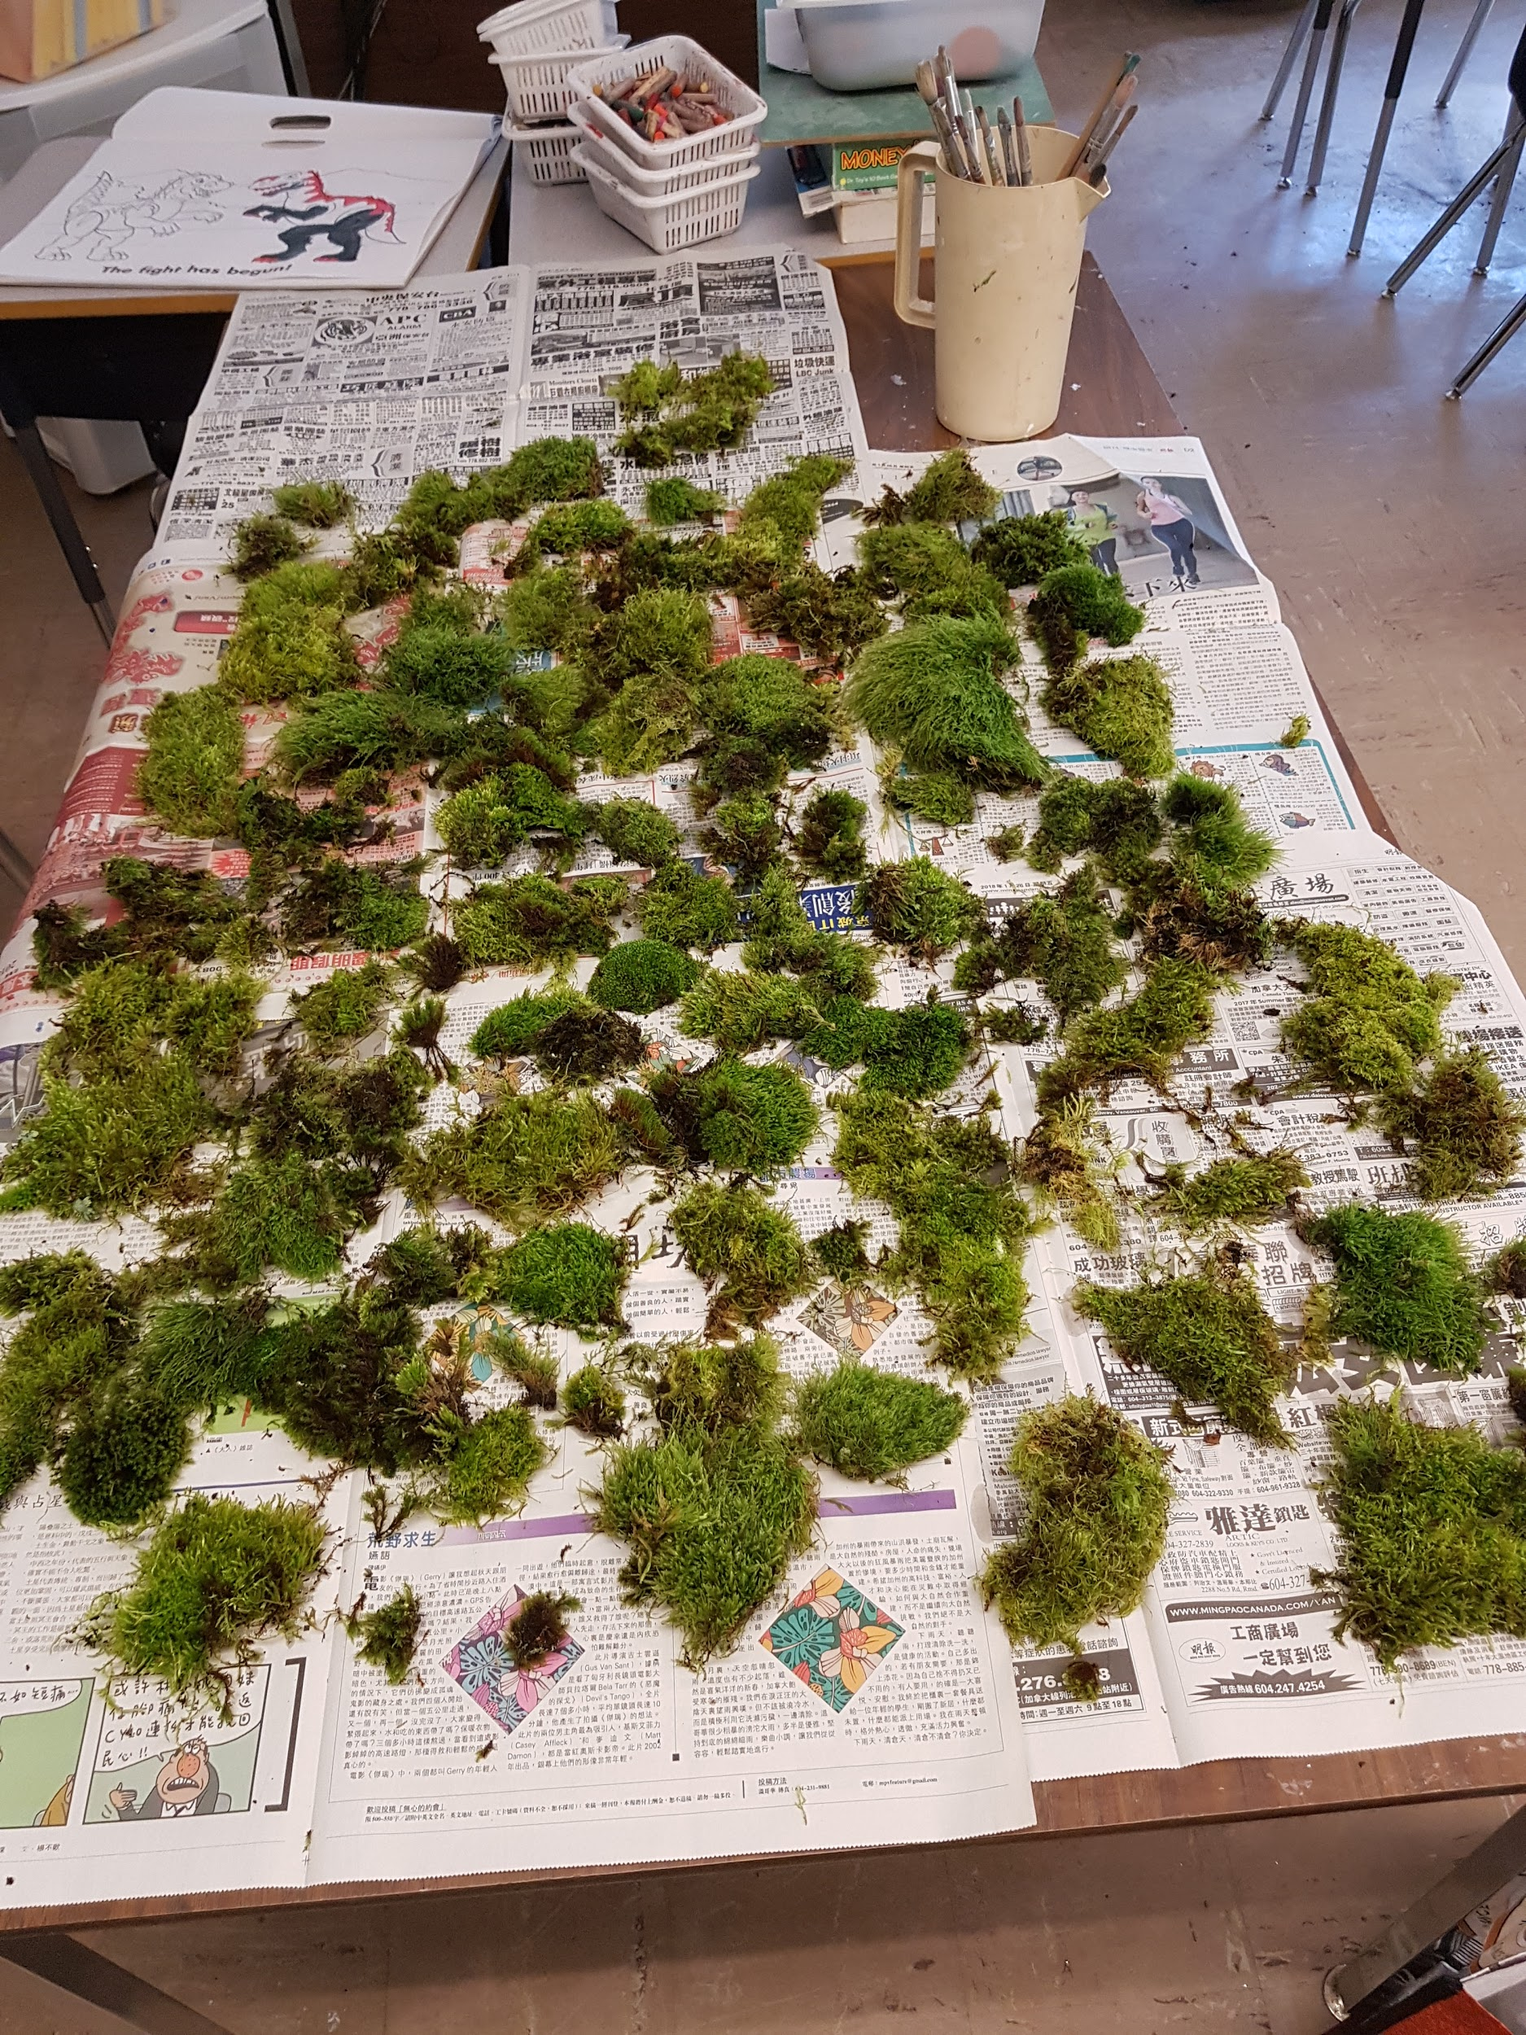
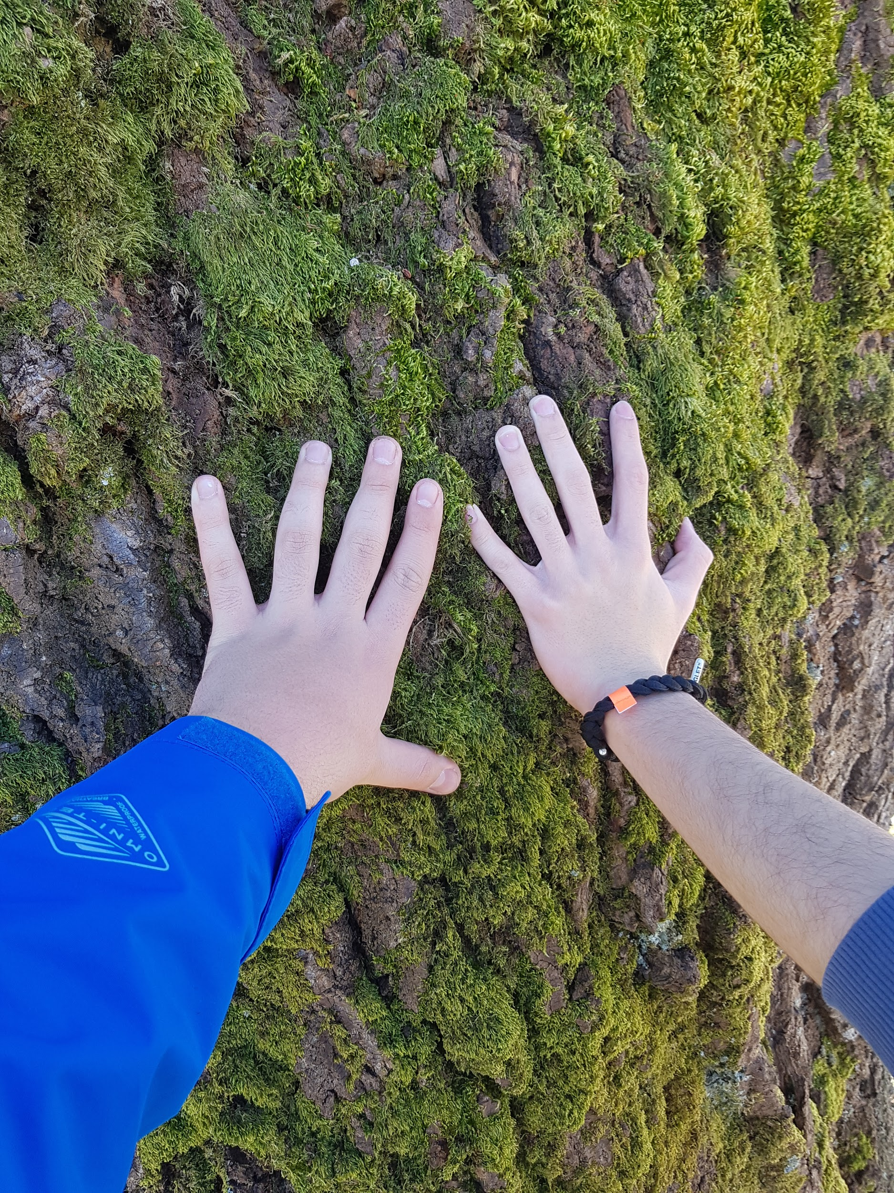

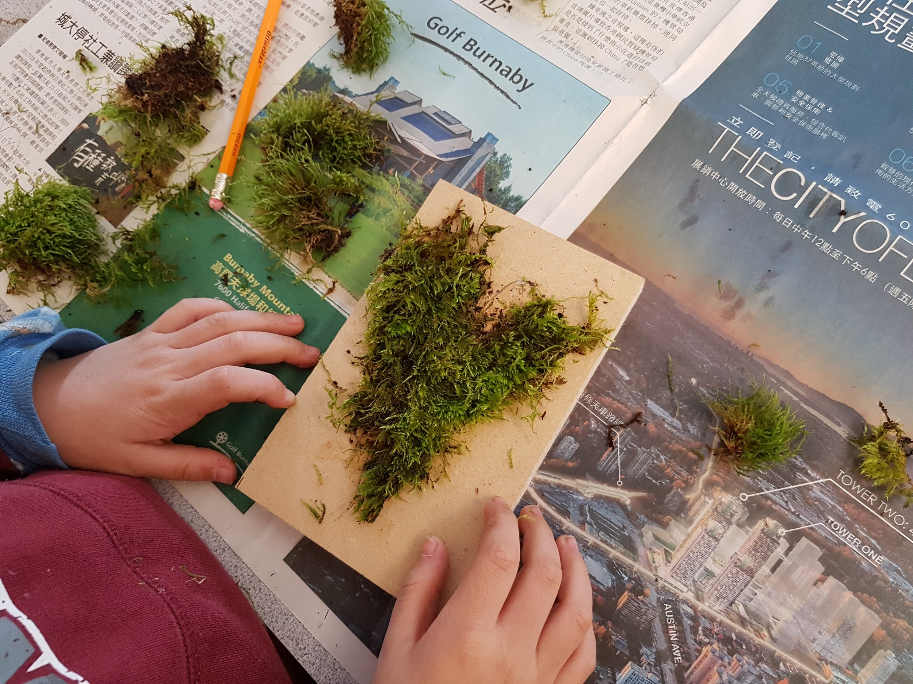
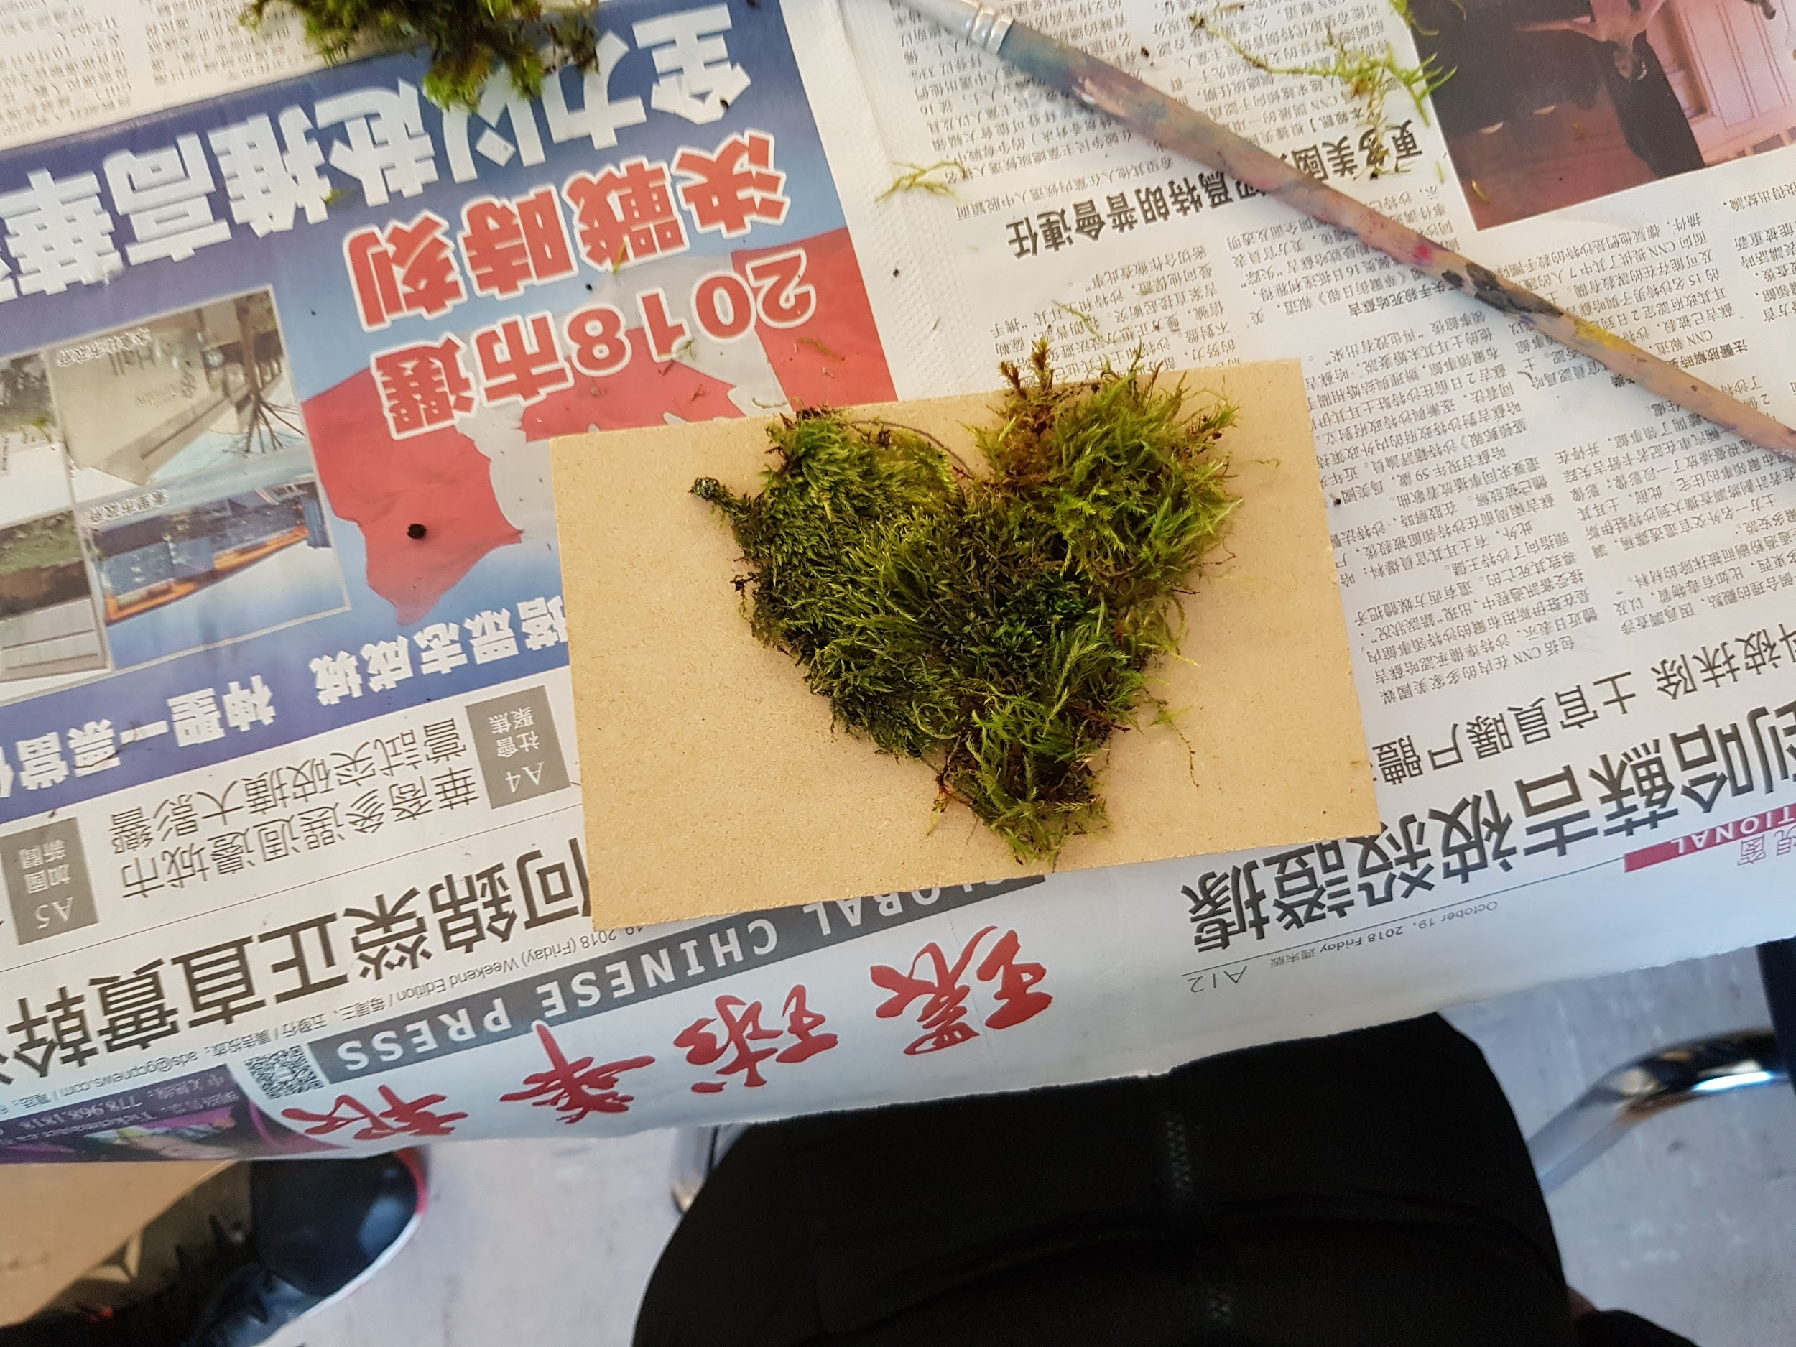

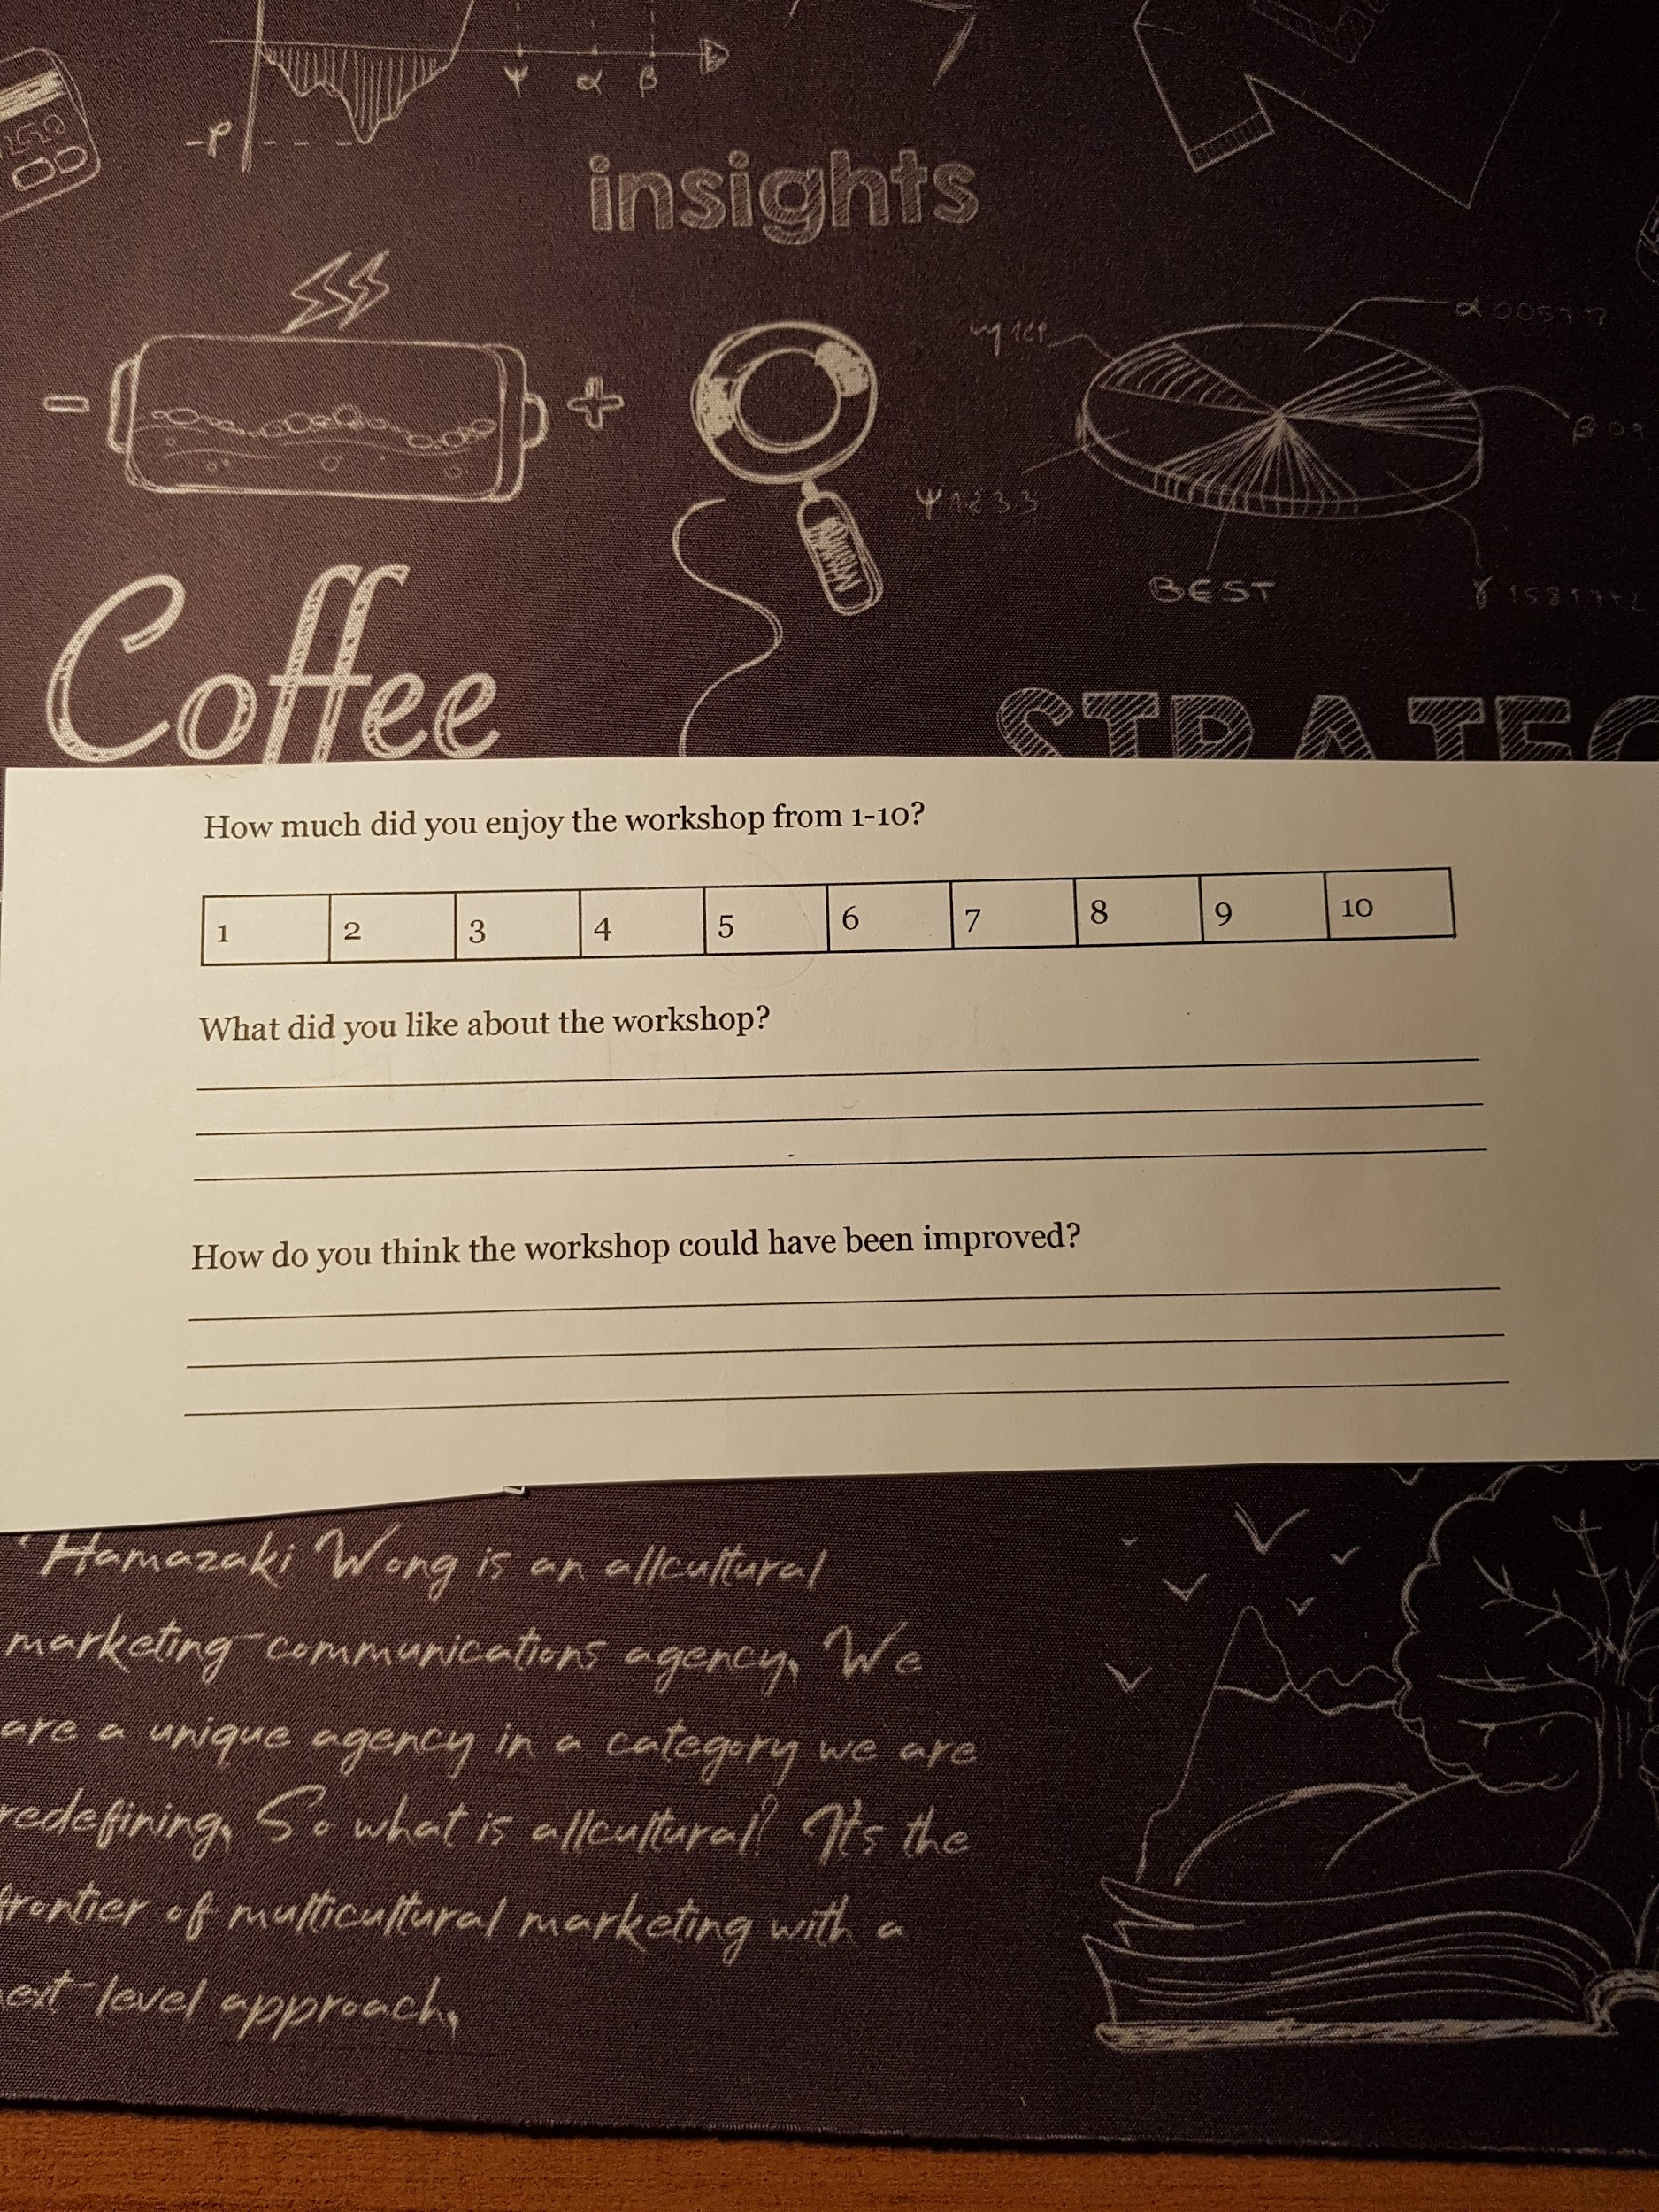

Outputs | Short-Term Outcome | Long-Term Outcome | Indicators | Data Collection Method
Engaging workshop | -Having fun with peers  -Learn a new art skill  -Balancing the school life with fun, engaging art | -Becoming interested in leadership roles, such as leading a workshop | -The average rating from the kids for the workshop was 7.8/10 | -Survey/  questionnaire  -Socializing with peers and with us, engaged in activity
Moss Tile | -Beautiful piece of art to add to their home  -A unique way to show gratitude to an important person in their life | -Foster a better relationship with whomever they’re giving the moss tile to  -Spark an interest in arts and gardening | -19 people will be receiving a tile, letting them know the kids are thankful for all they do  -All 19 people ended up finishing their moss tile | -Went around and helped kids decide who they were making the moss tiles for  - The message on the back of the tile showed compassion

