M’s Reflection:

When we were first introduced to the compassion project, I definitely wasn’t very excited about it at all. I spent a lot of time questioning why were we doing this, and what was the point. I didn’t really feel confident that I could do something special or something that can make me feel like I accomplished something good. However, after completing my project, I feel completely different about this assignment. My project is one where I can look back and feel proud that I did it because I truly believe that I positive impact in my school that may seem little, but big to me.

My partner and I spent many classes contemplating what we should do. All that went through my mind was: How does everyone already have a topic, and we’re stuck here struggling so hard to think of something that can show compassion. In the beginning, we tried to take the easy route, by choosing underwhelming topics, such as creating cards to give out or creating an Instagram page to somehow encourage more positivity. In the end, we had to let go of both of the topics, knowing that it’s not challenging enough, will not achieve the goal of creating a more positive school/ community environment, and I definitely wouldn’t have felt proud of myself.

We realized that if we wanted to do something special, we had to think deeper of an issue that we wouldn’t normally care about. Looking back into the last few years that I’ve been at Windermere, I realized that I was not super active and involved in my school community. But I came across a time where I participated in one of the Best Buddies Club’s Easter Hunt. During that time, there were only around 5 student volunteers that participated with the life skill’s class. We came to the conclusion that as students of Windermere, we often overlook this certain group of students and wouldn’t care about them.

For our compassion project, we aimed at creating a bouquet of flower for the life skills class, setting a long term goal hoping that the class will recognize that they’re not always overlooked by everyone else in the school. I had a lot of concerns along the way and didn’t feel super confident that my project will succeed the way I want it to. In order to truly accomplish that goal, we decided to do a flower folding workshop called “Power Flower” during lunch hour at Windermere.

Knowing the type of people in my grade, I had a big concern that we wouldn’t be able to find people who would be willing to participate in our workshop because most people simply wouldn’t care. On the week of our promotion, I went around asking people to attend our workshop, but I was only able to find ~4 people, even after I tried really hard promoting our cause. We also made a mistake by overestimating the power of food as a source of attraction.

Once again, we tried to take a safe route by asking the people in our Leadership class to join us, along with the ~4 people we got, even though we knew that this wouldn’t be a good idea because we are supposed to reach out to our school community. But we were reminded that our project will only succeed if we show that students, not part of our class, care about our cause. My heart sunk because our workshop was in a couple of days, and I had no idea we were going to find people. I realized that our project, as written in our proposal, has a huge potential to actually create an impact and leave a mark in our school, or at least the lifeskill’s class.

On the day of the workshop, we were able to achieve our goal of finding more than 10 participants, with a majority of them not being in our Leadership. There were 7 non-leadership, 5 Junior Leadership, and a couple of students from our class - definitely surpassing my own expectation.

After explaining the reason behind the workshop, I heard a Junior Leadership student (who I asked to join right before our workshop started and had no idea what was going on) say: “that’s actually a really cool idea.” I began to feel a lot more confident that our project will succeed and we will accomplish our goals. During the workshop, I was worried we wouldn't have enough time to finish folding the flowers because the craft was a bit more difficult to teach to a large group than I thought. But by the end of the workshop, we were able to fold ~20 flowers - enough to create a giant bouquet. I felt very gratified that we were able to bring students together to construct the flower.

Even though we’ve already gone through many speed bumps, I had one last big concern that worried me a lot, and that was whether the lifeskill’s class would care about what we did. After presenting the flower to the Best Buddies Club, I was finally able to see my project come together in a circle. I was able to see the students smile when they received and opened up the flower. I felt my negative energy about my project finally turn positive after I saw a student receive a flower and saying “look, it says “I love you!” and this is my favourite colour too” while she happily showed her flower and message to everyone around her. While handing out the flowers, I was able to talk to one of the teachers, Raymond, and a person who was part of a chapter of Best Buddies Canada, who both felt very impressed with what we did and taking this initiative. It’s been a long time since I’ve had a burst of happiness from school.

After completing my project, I’ve learned a lot of new things and understood the meaning behind this compassion project. In the beginning, we were confident in our idea, but I had no confidence that my project would succeed the way I want it to, but it turned out that I was wrong the whole time. Even though we had an amazing proposal, it was hard for us to not to try to take short cuts, but I learned along the way that we had to put our absolute best effort into making our project a success, and that’s what we ended up doing. I feel proud knowing that I was able to create a positive impact in our community by bringing students together to create something special for the life skills class.
Project Completion Sheet

Power Flower is a project done by two students in the Windermere Leadership program. Our project intends for high school students in our school to show more thoughtfulness, care, and kindness towards Windermere’s life skills class - while also working to encourage a more positive school environment. We have participated in past Best Buddies club where we worked alongside the life skills class. We believe that it’s a need to do this project because we feel like the life-skills class is overlooked far too often by the rest of Windermere's Student. Our team will run a workshop where participants will have the opportunity to create “power flowers” (a folded origami Lily with a kind and positive message inside), which will be delivered to the life-skills class. We really hope that our participants understand how small actions like folding a little flower and writing a kind message can have a positive impact on the person receiving it, and also the school community. Our project could be a starting point of spreading positivity, where the participants of our workshop, may take on a project like this in the future.

Output | Short Term Outcome | Long Term Outcome | Indicator | Data Collection Method
Participants folding origami flowers for the life-skills class /  High school students participating in this workshop | - Bringing the community together to do someone good.  - Fold enough flowers to create a big, beautiful bouquet.  - Making the school a better more positive place | - Participate understand how small actions, like folding a flower can have a powerful impact in creating a more positive environment.  - They may also do a project like this themselves. | -We were able to bring 12 students (non-leadership 10) together. We were able to create a bouquet with ~20 flowers  - Through our survey, more than 75% of participants thought that they made a great or fantastic impact on the school.  - Over 70% of participants will consider taking on a project like this themselves in the future.  - Throughout the workshop, participants have said that they think our idea to show compassion is cool and interesting. One participant responding to my question (along the lines of): “It’s a good idea to surprise them because I do think that we forget about them all the time” | -Photos are taken of the participants and flowers  - Participants will be asked to take a survey at the end of the workshop  - Record how they feel while and after doing the workshop
Participants thinking and writing down positive messages | - Participants feel good knowing that their kind message just made someone’s day better. | - Participants will keep on writing positive, kind messages to their friends or loved ones. | Through our survey, participants have said that there’s a good chance they will feel happier if they received a message like the ones they wrote and will consider writing more positive messages. | - Participants were asked to take a survey at the end of the workshop.
Life-skills class receiving the origami flowers | - Brighten up the day of the students  - Students will feel happier | - Recognize that they are not always overlooked by everyone else in the school. | Many of the students were smiling and looking very happy when they received and opened the flowers. One student said: “look, it says I love you! and this is my favourite colour too” while she happily showed her flower and message to everyone around her.  Raymond (an adult responsible for the class) said after we presented: “this is very impressive that they took the initiative to bring students together and create this flower for you guys”  A worker from a chapter of Best Buddies Canada had a conversation with us and said: “This is the first time I’ve seen someone do this for the best buddies club. This is amazing” | - Expressions recorded while the flowers were passed out.  - Talked to the teachers

Participants:
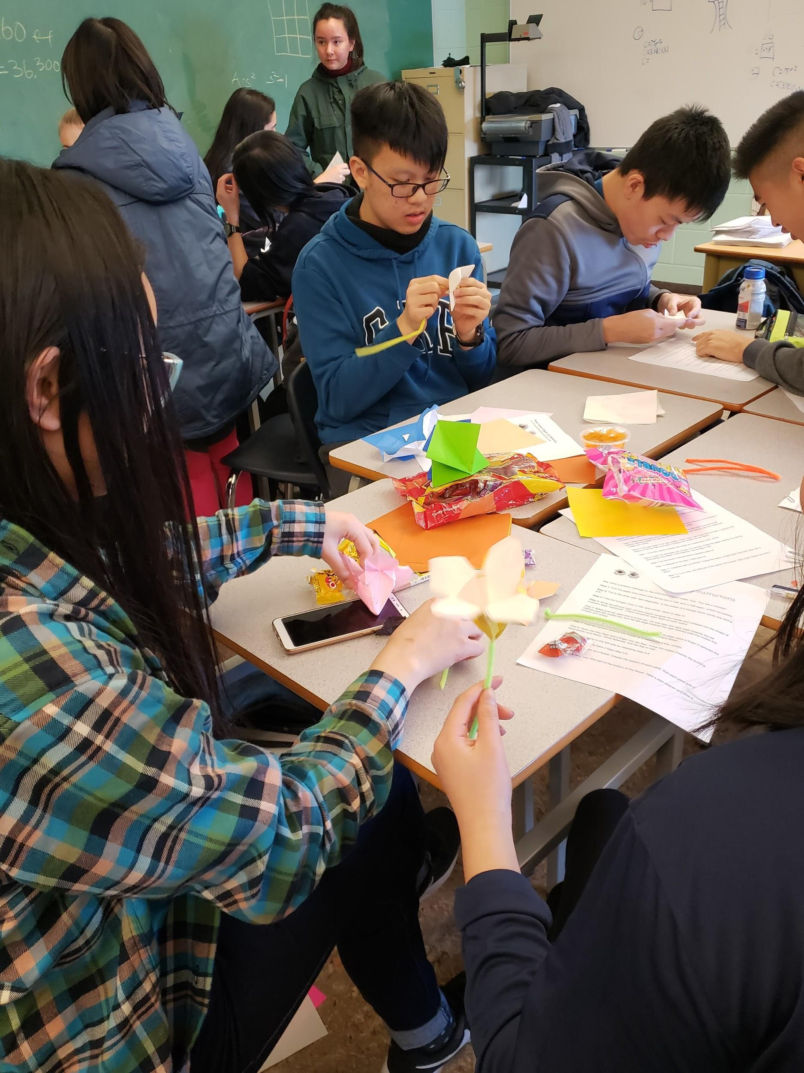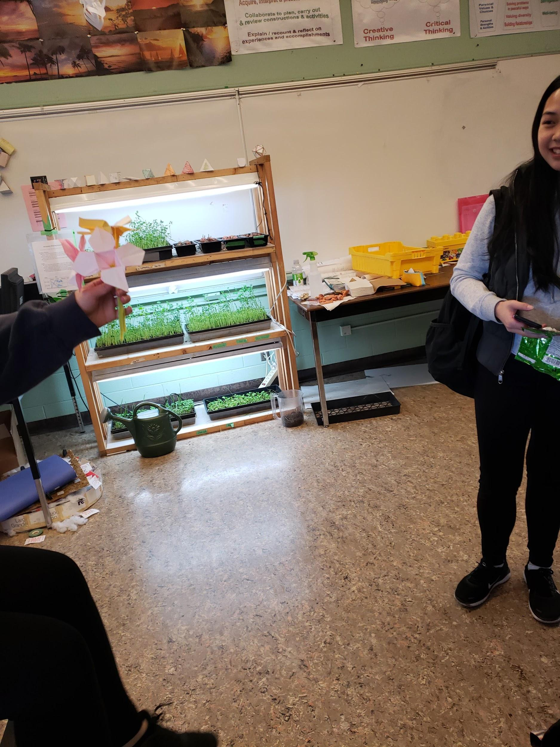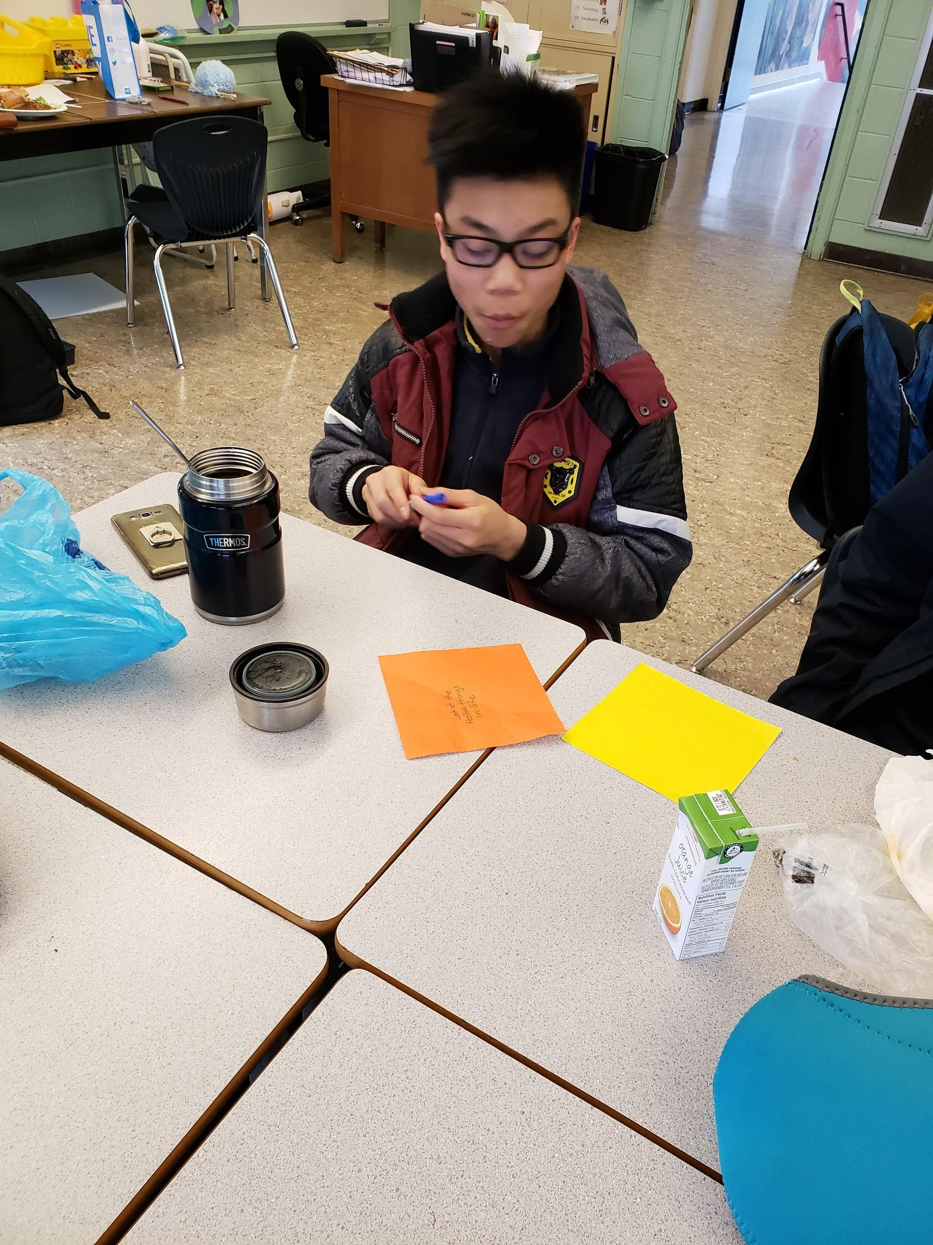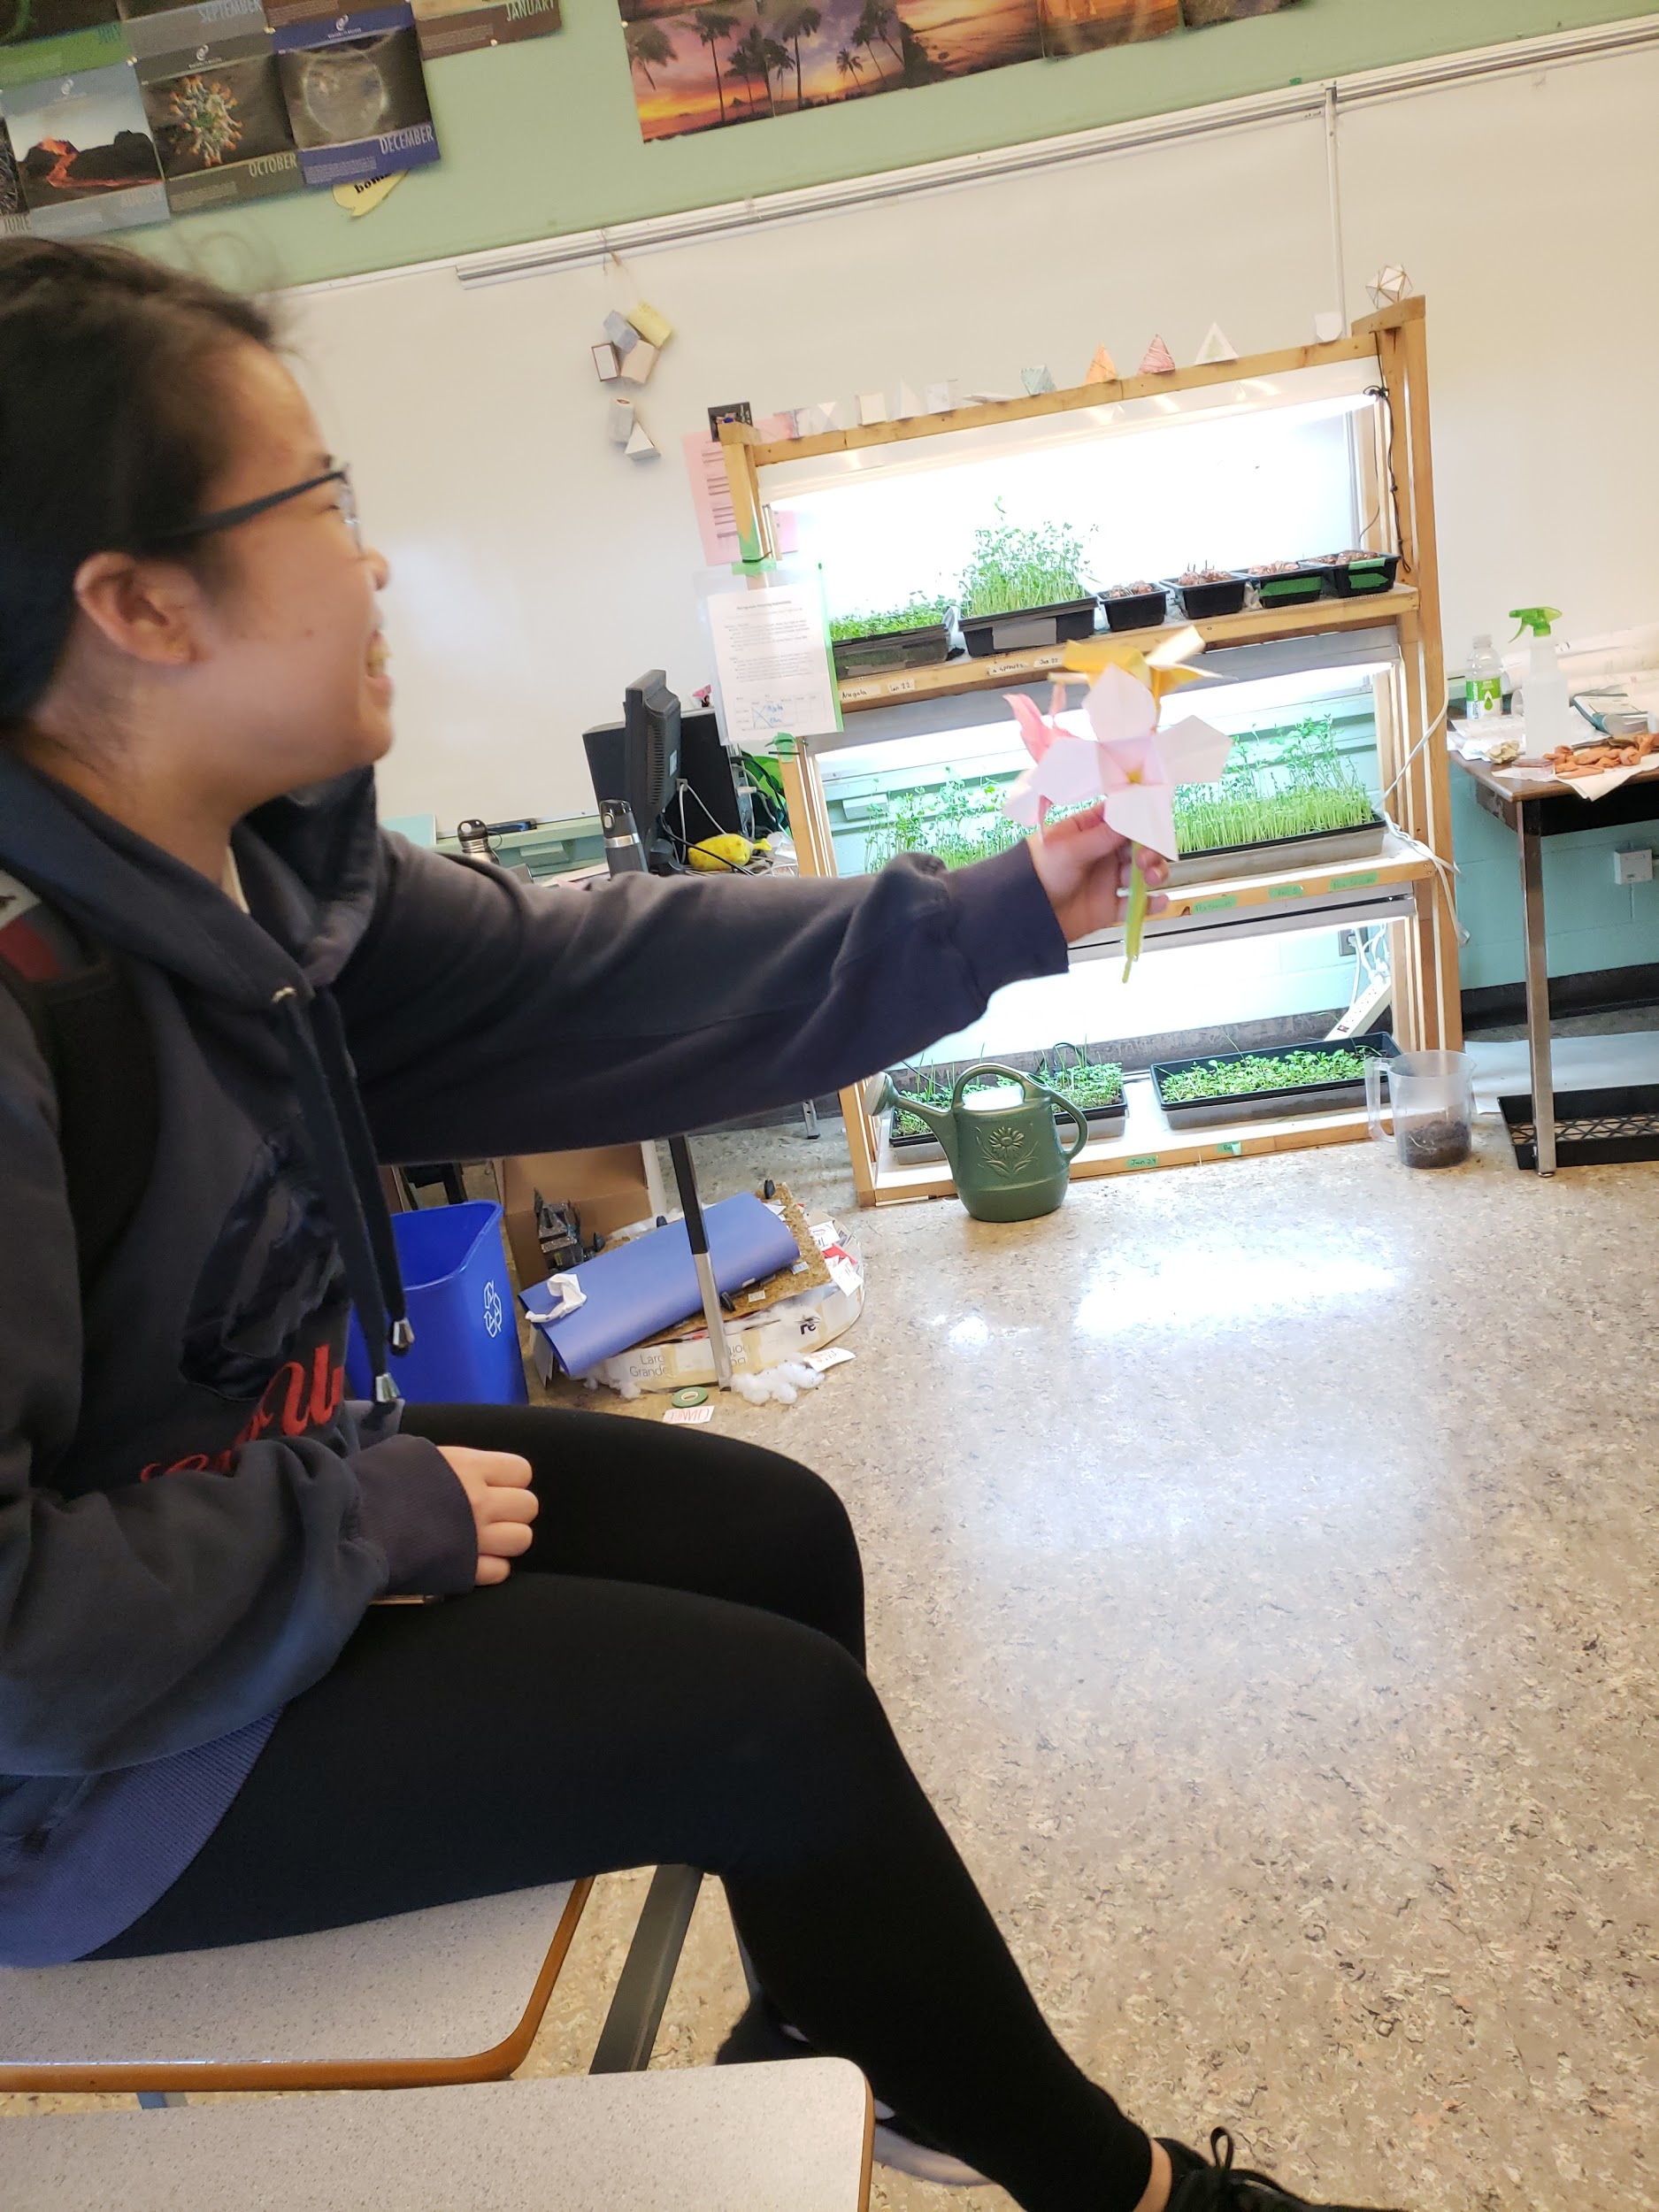

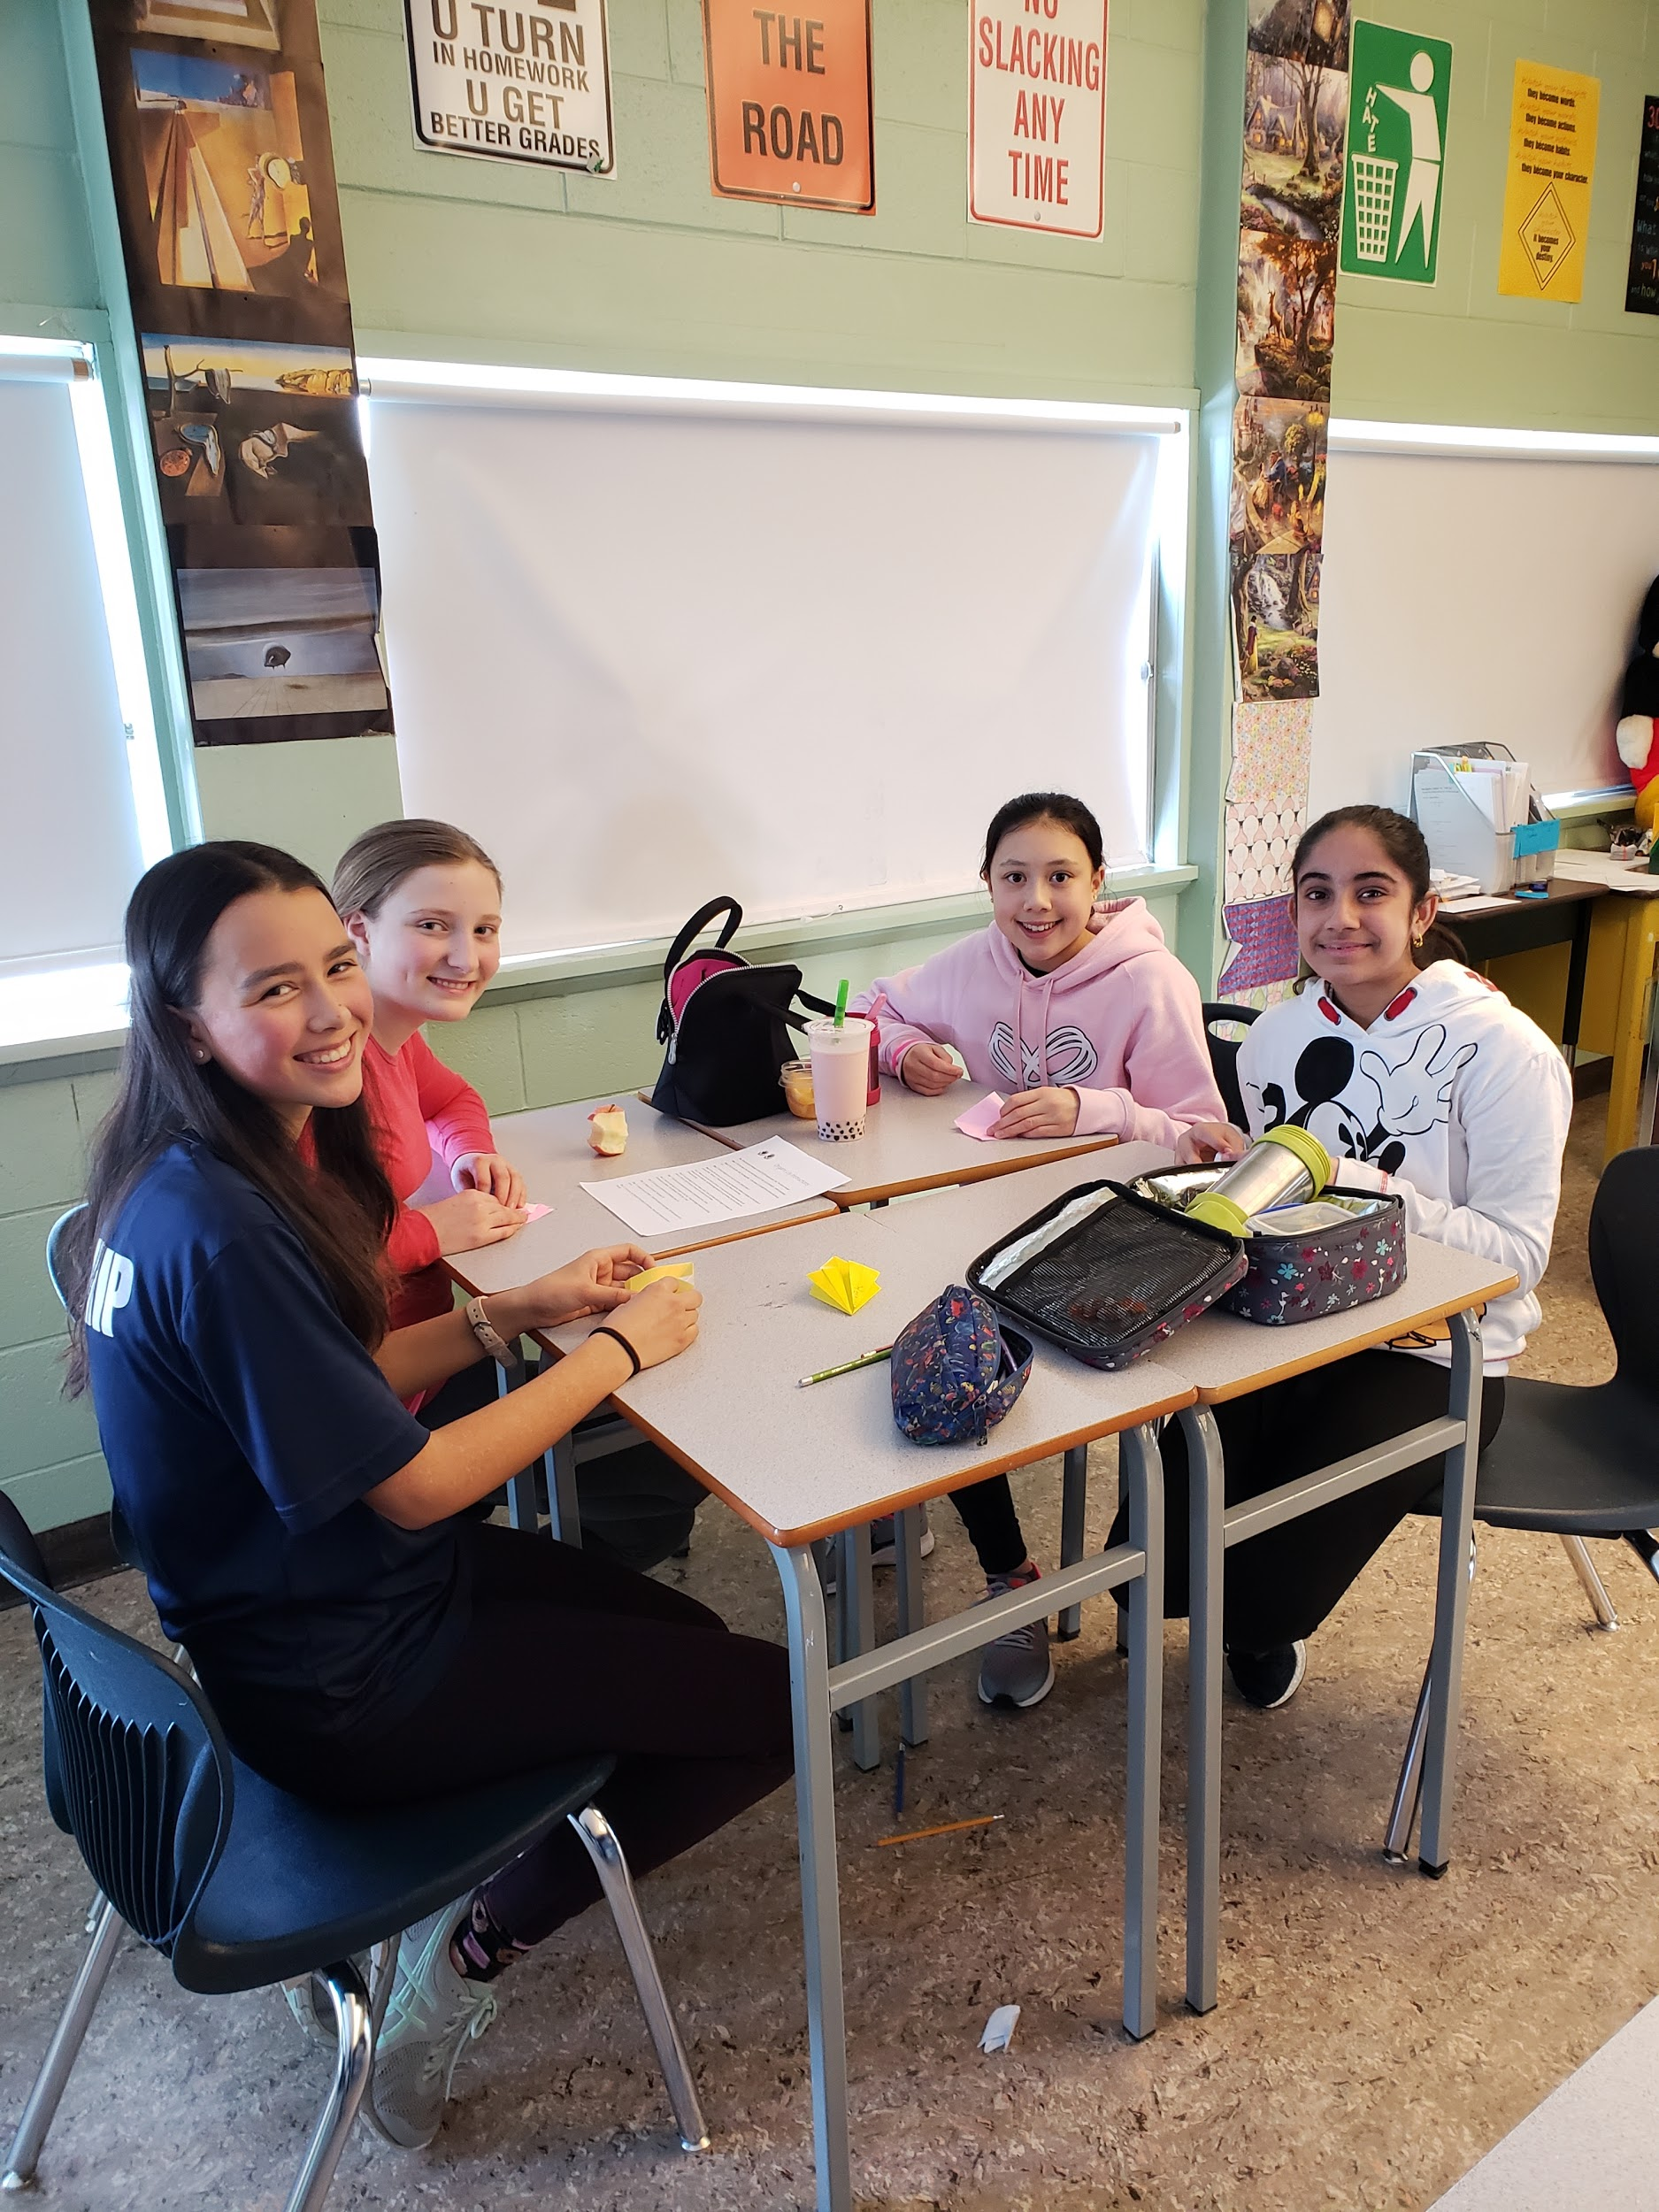

Positive Messages/ Survey:

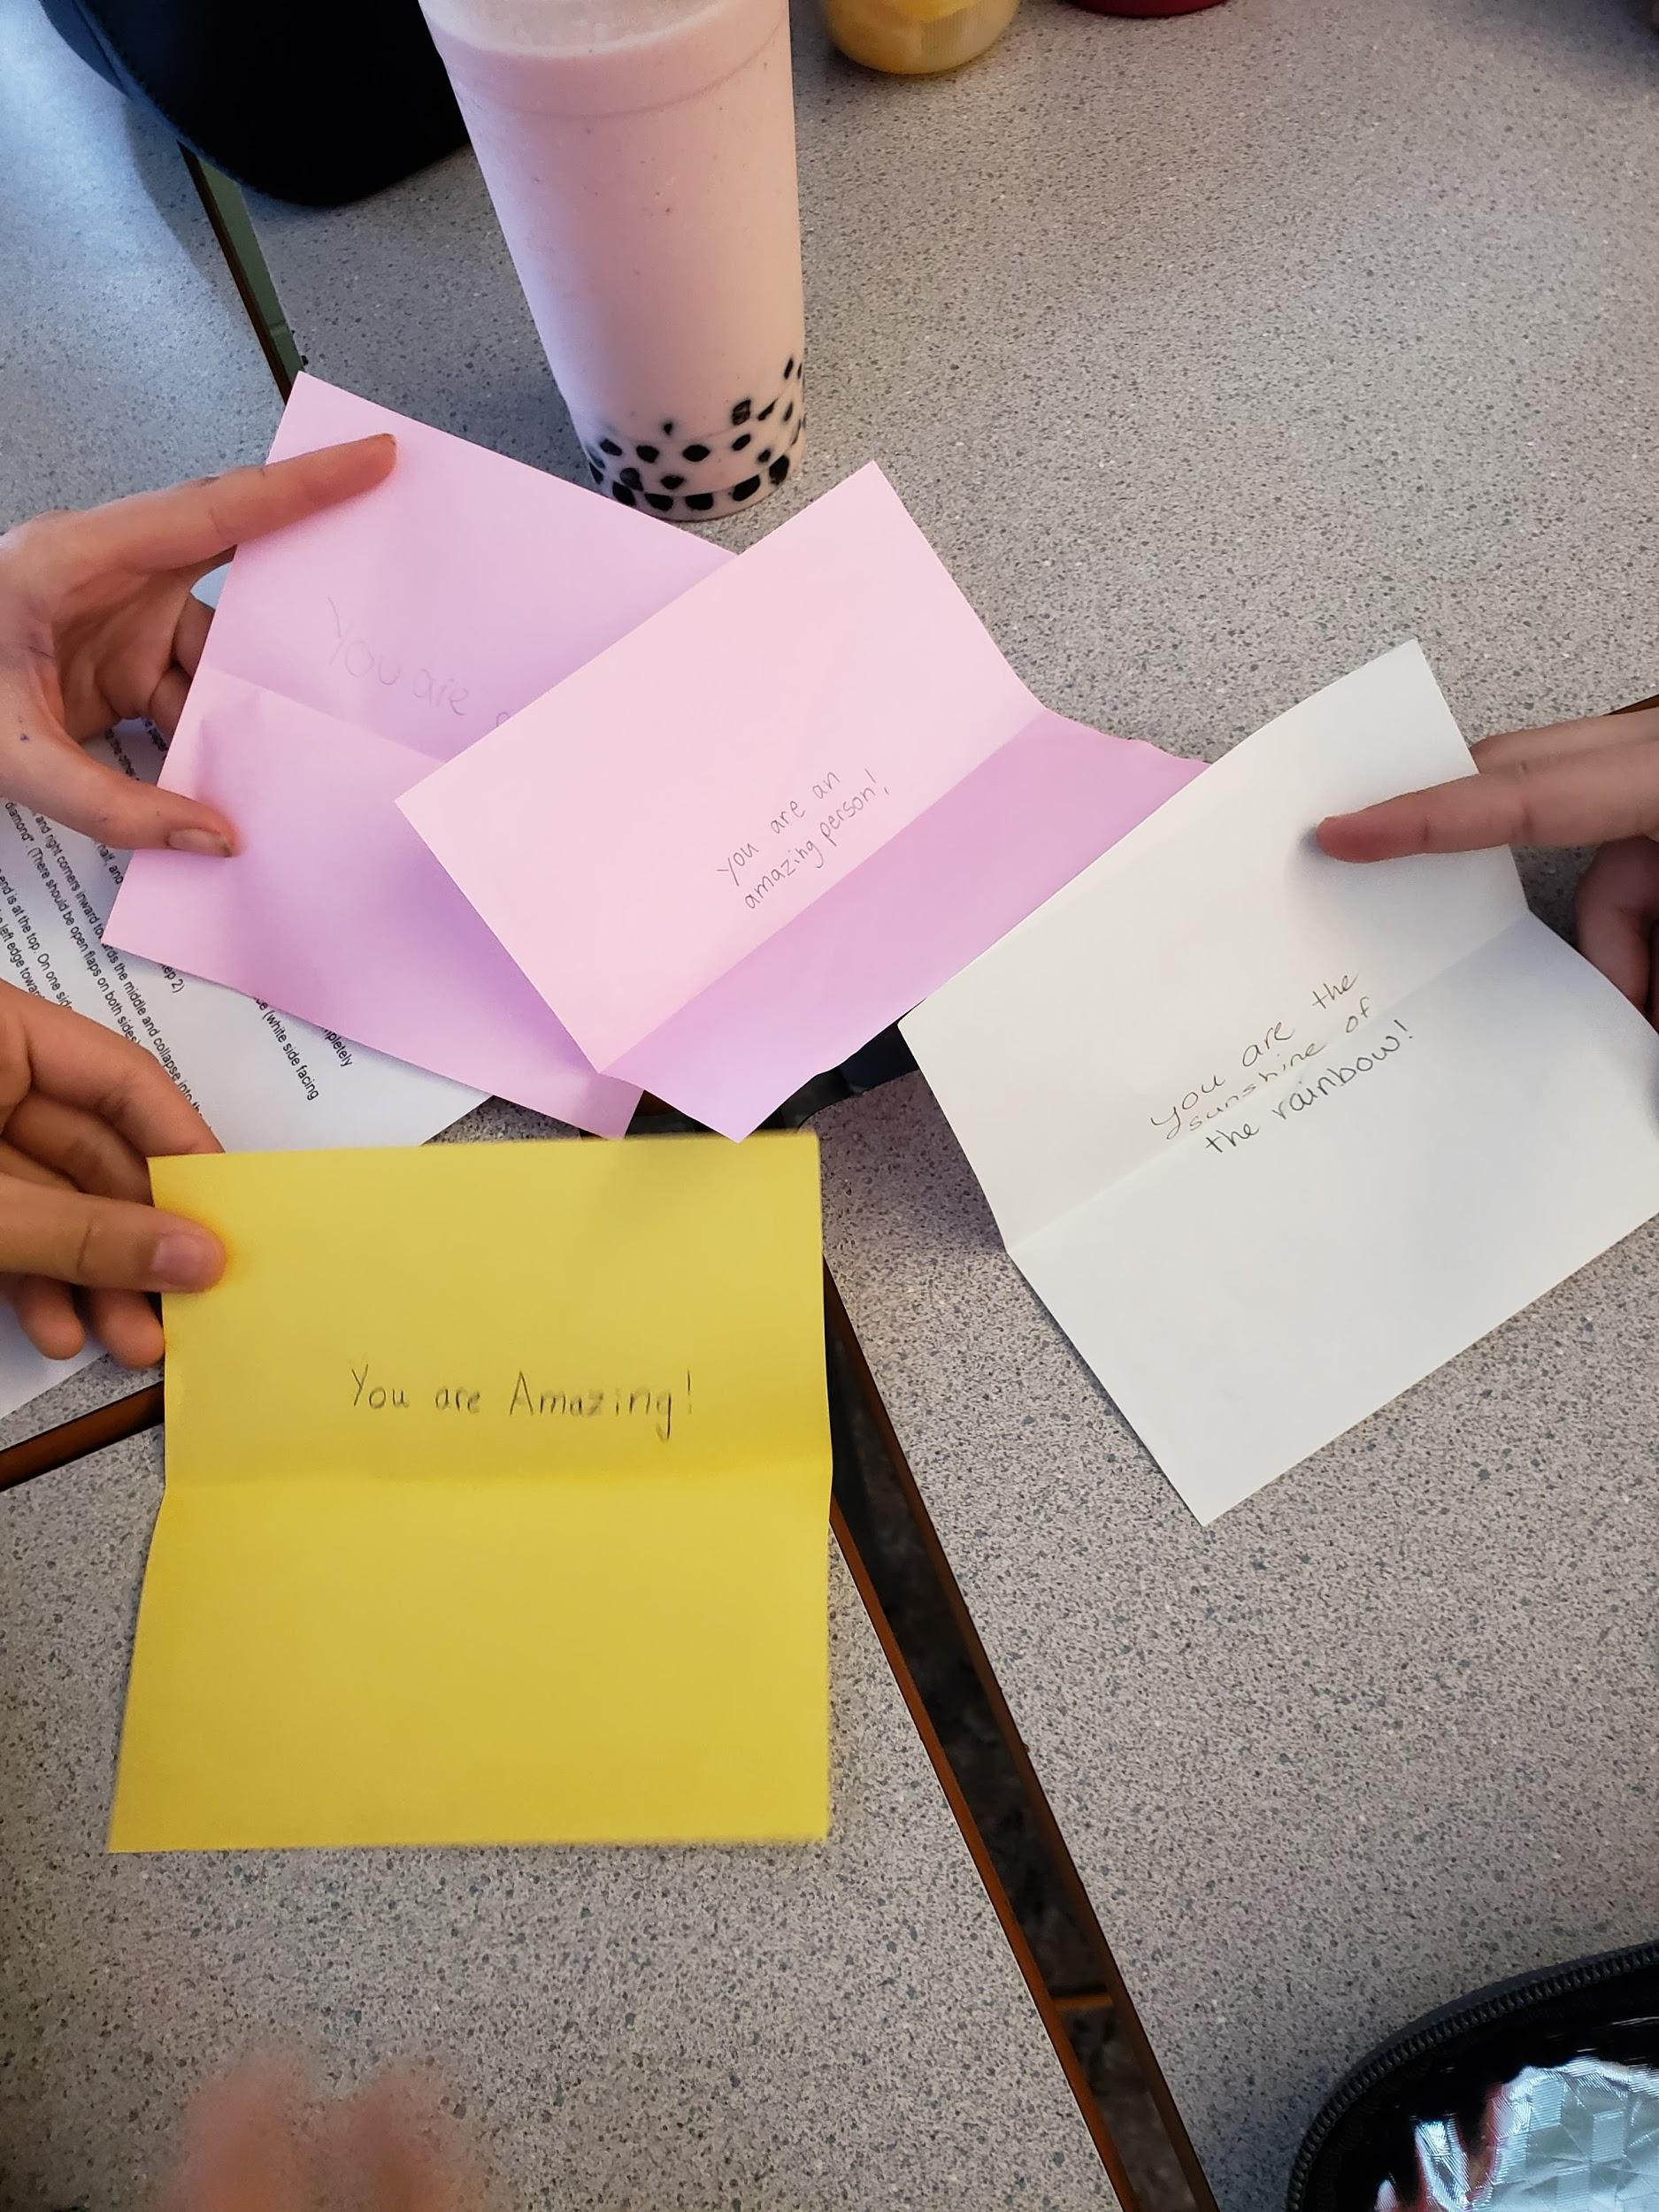

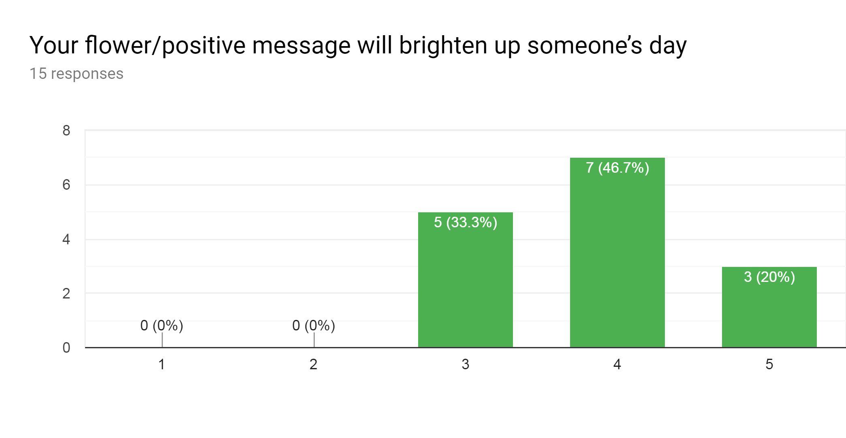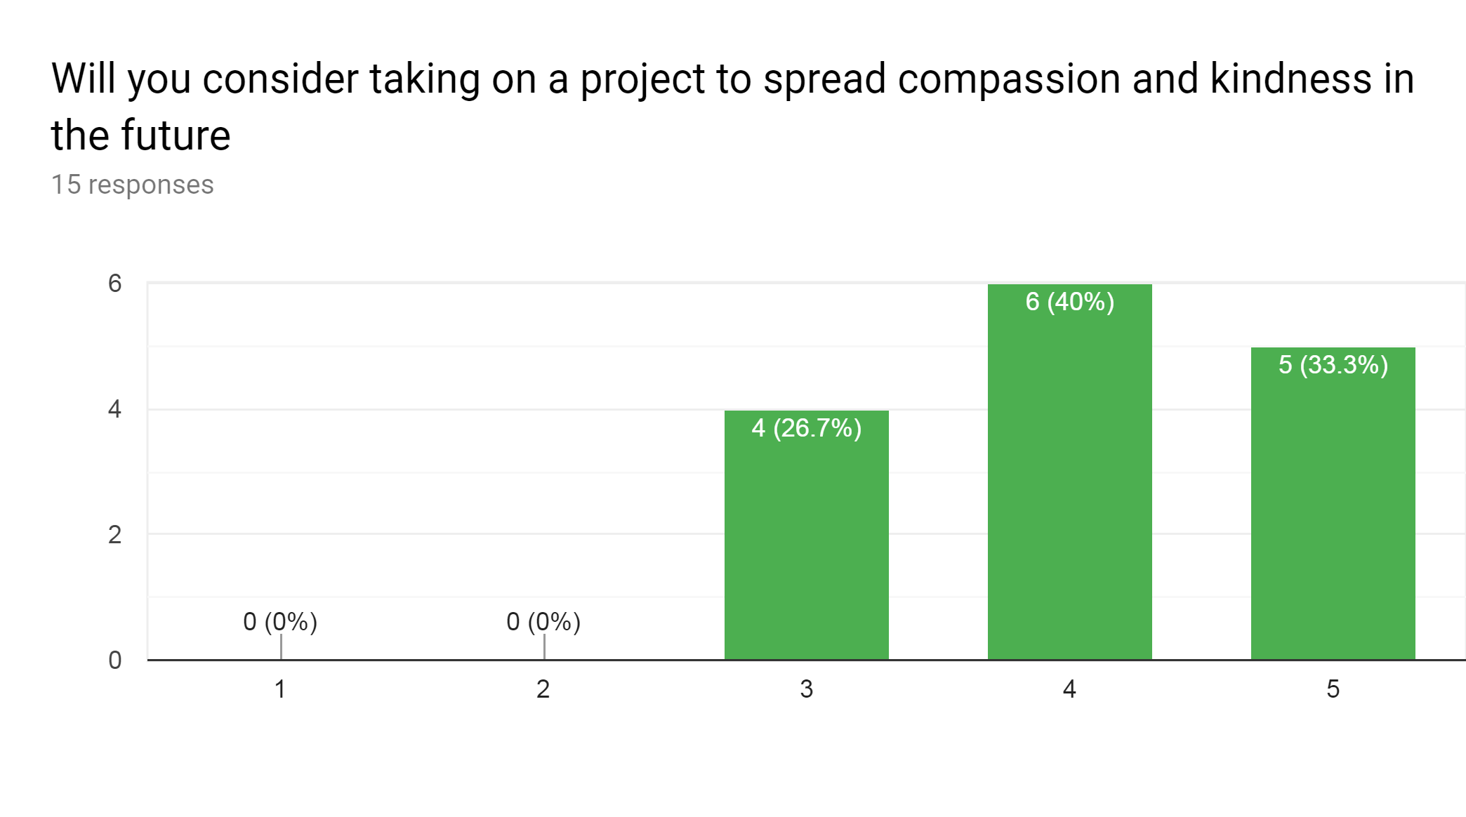
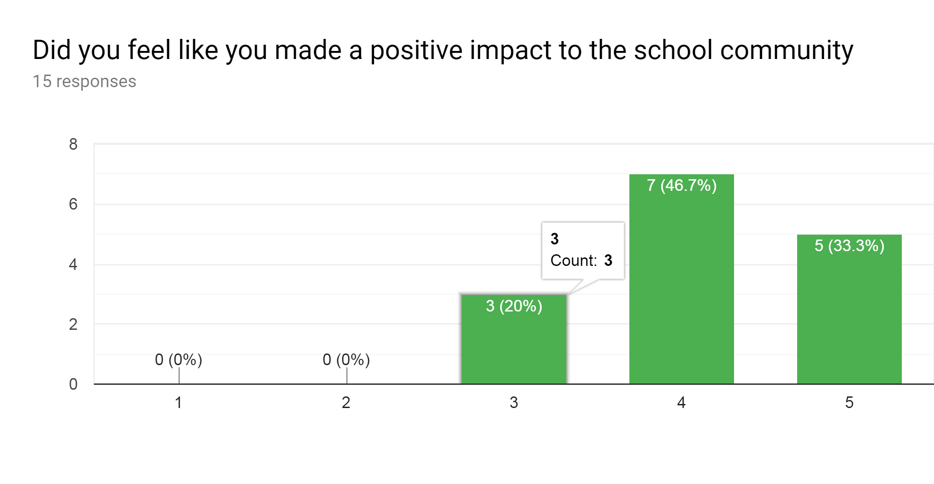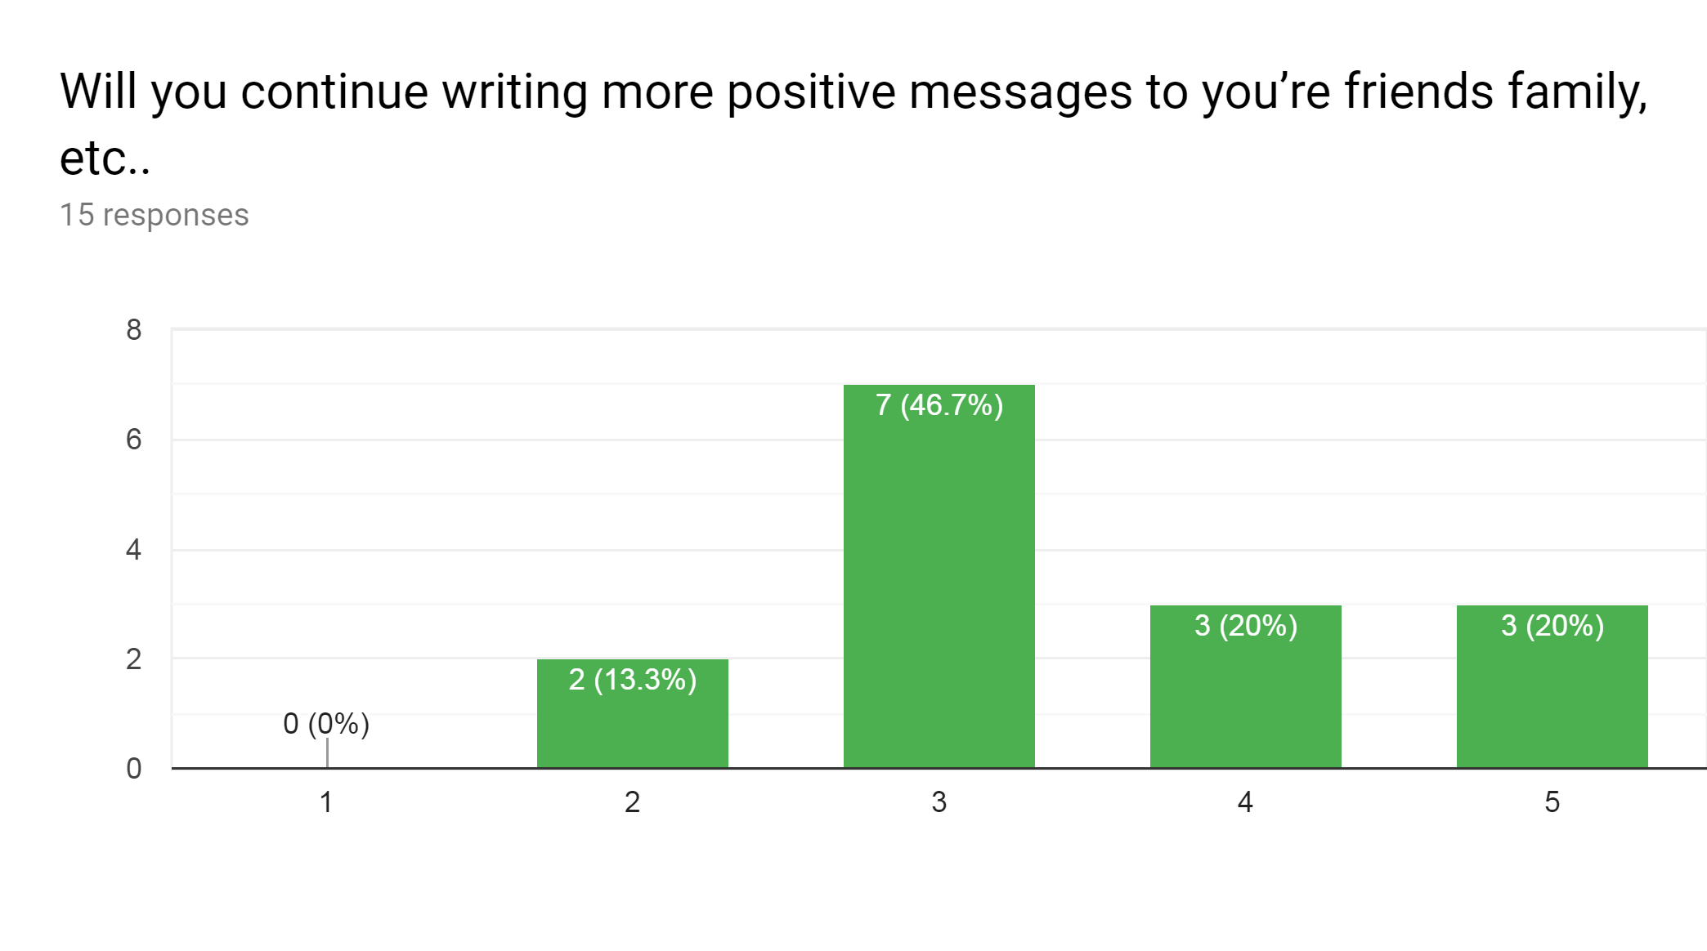
Students are ecstatic to receive their flowers:

