Project proposal summary R and K

Outputs | Short-term Outcome | Long term outcome | indicators | Data Collection Method
The notes | - being happy for a day or a shorter period of time when they get the note  - they will feel better and more happy for the day  - They will feel a little better because they ate chocolate while reading the note  - Better wellbeing for the day | - It will help improve their happiness overtime with them knowing that someone took the time to make it for them  - It might make the community better because they might get the urge to do something compassionate for another person. It might also make the community more together and stronger because people are happier and  - It could help spark the thing they needed so they could keep going and keep being happy | - 64.5% of people say that it has made then happier  - Some people are saying that it helped them build self-confidence and gave them a better mood  - When people left the box they looked happy  - They were all gone in a day | - The survey we put the link on the letters and online and 14 people have responded to us  - We have gotten positive feedback from our friend that they liked it  - How many people took a note out of the box

R’s Reflection

Through this project, I have learned that just one compliment can help you throughout the day. K and I helped a lot of students throughout the school according to our surveys. When we first started, we had a clear vision of what we were going to do but there was some trouble of timing and working together. This project really taught me that you need to think out of the box and think creatively. I’ve also learned that you need to put a lot of effort into a project where you have so much freedom to do whatever. Overall I feel that I didn't put my best in this project and I feel bad for letting my partner do everything.
K’s Reflection

Throughout this project, there have been many ups and downs. When we first started my vision was clear and I knew exactly what I wanted to do almost if it was kinda calling to me but when I started it became more of a side project then my main focus which is one of the reasons there were troubles. This project has taught me a lot of some good and some bad. The good was I finally found my limit and now i

know how much to push myself and how not to push too much to the breaking point, and also the response we have gotten was pretty good. It has also taught me the power of one compliment it can help change you for the better. During this project, I wish I had self-regulated more and not pushed to get this project done so quickly and took the time to put more effort into it. Some of the hurdles that we had to jump through were just timing and trying to manage that well with all the other projects we both have going on and the ability to adapt to new challenges like the fact that no one was really doing our survey. So I think us trying to get through that showed that we didn’t really think everything through even tho a lot of people were taking the notes and we did get about 14 people to do our survey.

My true goal during this entire project was to try to make people happier and make our community a little brighter. I fell as I have sort of succeed in in a small way because when I would go look at the box and see people walking away from it they would always be smiling while reading the letter. This project has given me joy and the sense that I have done something in our community and even though it was a small accomplishment it still meant the world to me. Seeing people happy and smiling because you have touched them in some way is why I volunteer and is why I have chosen to do this project. Some of the things I have really enjoyed doing was making the cardboard hearts with Ryan at my house and also getting the satisfaction of having something that I made on the walls of Windermere. Overall this Project has really taught me a lot it showed my the ups and downs of partner work and it showed me that I showed have put more effort and not pushed projects to the side and be a procrastinator. But throughout this, I have always tried my best to make this work and I have tried to put my full effort into this project

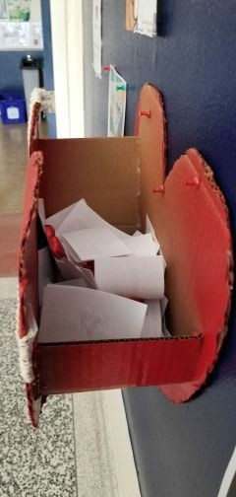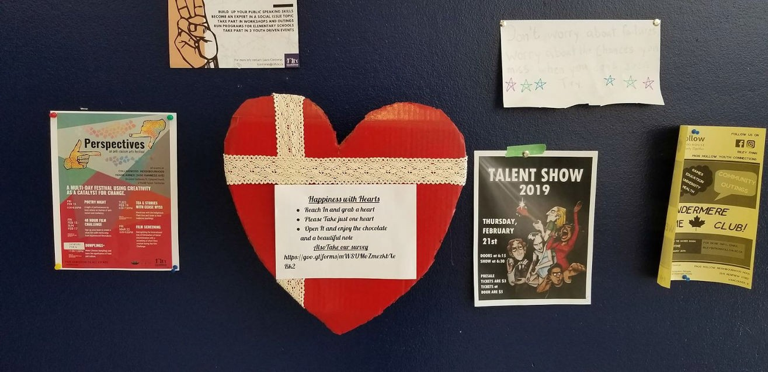Link to our survey results: https://docs.google.com/spreadsheets/d/1Y958fcPPJmSmnBkLDCXVhmiMz3U5hkCiP3ATyhsesfk/edit?usp=sharing Some Pictures

