“Beary” Good Card Making Workshop Reflection

Outcome | Short Term Effects | Long Term Effects | Indicators | Data Collection Method
At least 30 cards made in the workshop | Everyone gets to make at least one card. | The children will have a new skill in their minds after making these cards. | Each children received materials from us, and we will contact the teacher for final results. | Contact Mrs. Cheung for the final results of the Cards.
Workshop after the cards are made | The children give the cards to the people they find important in their lives. | Hoping to create a positive community through spreading affection, by giving out these cards. | Mrs. Cheung has already sent the cards home. | Contact Mrs. Cheung to tell us about who the kids gave their cards.
Problems that may happen | Kids may lose interest in the workshop | Kids doesn’t give cards to the person they wrote to
More Down Below!

Reflection
Mar.1, 2019
By A

My compassion project “Beary Good Card Making Workshop”, has been a great experience. Everytime it was a special occasion, my sister would make a card to the special person celebrating on that day. My sister, J would put all the effort she had into those cards to help show compassion to others. J, inspired me to do this card making workshop, because it may be simple, but inside the card has a deeper meaning.

Doing a workshop for the first time was very difficult. When trying to prepare for this workshop you need to focus a lot on the little parts. When trying to do a workshop I had to find the email of a principle, which can be very challenge and Brendan had to help me find it. Once the principle accepted my card making workshop, it would be my job to communicate with the teacher professionally. Communicating with the teacher was very difficult because, it is challenging for me to act serious.

Now that I have communicated with the teacher, my job is to get the materials needed for the workshop. When trying to find the materials needed for this workshop, I decided to go online, because in my mind that was the most convenient. However, when going to the store in person, they may not have the products you desired, so I had to make a compromise and buy different materials. Once it has come near the date of the workshop, and thought I had all the information I needed. We forgot to ask the teacher one small detail, which school she was from. So we arrived to Norquay instead of Renfrew, which was where the teacher taught at. After we arrived at Renfrew late, we did not have enough time to see the kids complete the cards. But the teacher decided to take it into her own hands to help complete the project. Which was very nice for her.

In the future when I do more workshops, I will take in all of the possibilities that can occur. The next workshop I host, I will communicate better with my partners helping me. Whether it be location or time. Next, I will have to be more prepared when finding the materials need. Maybe not relying on the websites and try and find what I needed in store. As a result, all of these experiences have helped my skills as a host for a workshop and more.

G

March 1st. 2019 Term 2 Reflection

We are all predestined for greatness-- but not everyone reaches that point. All our classes are so systematic, that I’ve been pushed to think that my creativity has limits. This was something I’ve been thinking of during leadership class. My class and I have been taught to get out of our comfort zones and get engaged with the community. So towards making a bigger difference, we had to take small steps. To show compassion to our community, Andy and I made a “Beary Good Card Making Workshop”.

Planning my own workshop is definitely more work than I expected. We had to plan for every little detail in running our workshop, in case we had some obstacles or that compromises had to be made. Emailing each principal to promote our workshop was also a very difficult part as we had to act as professional as we could to get their attention. A & I were also worried that the principals would not reply to us, and that we could be emailing other schools a bit farther out of our catchment. Also, at the time I did realize how challenging it would be to find an email list our feeder school principals, so Mr. Chan aided us with that. What I did find frustrating was that the principals did not directly reply to us, but rather only forwarded the email to their teachers, which I do not recall if I did specify for the principal themselves to email us back.

Since A bought our group’s materials, I had to pay him back; he had also done the example for our project, which I still admire his artistic skill. It was then time, were going to run our own workshop. The day of our workshop, we walked to norquay to help Mrs. Cheung’s class. But to our surprise, there was no Mrs. Cheung at Norquay. Although we did had thought we had all the info we needed, we had forgotten to ask what school the teacher was from, because she had not specified what school she was from, nor did the principal of any school reply to us. My mistake for making an assumption that it was the Ms. Chang at Norquay. So we had asked the secretary at norquay, and A and I were directed to Renfrew where we ran the workshop successfully.

For future workshops, I will take all possible details into consideration. Also to confirm with every person I may contact, I promise to communicate better with all my partners. I will never make any assumptions, which could compromise our workshop, and all the hard work would be wasted. Overall, these recent experiences have helped me to become a better workshop planner, and more detail oriented.

Card Making workshop pictures and captions
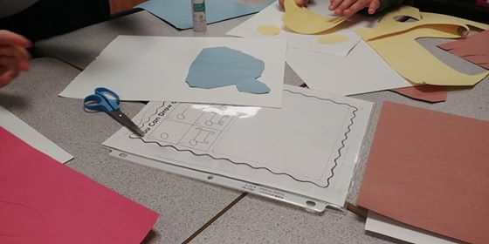
We all have many ideas that we fear to execute. This student decided to think outside the box and attempt to draw a dog. The child decided to ignore those little voices in the back of his mind and do what he wanted.
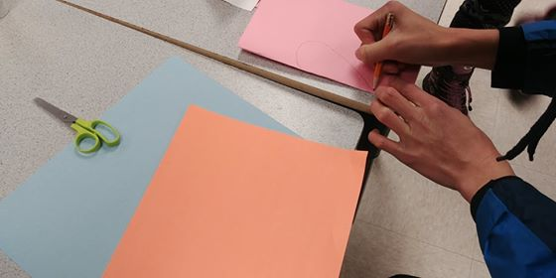
Sometimes in life, people do not like to ask for help, because it may cause them to look weak in some way. But a little girl decided to ask Garrett to help her draw a heart. You should never be scared to ask for help, and think it makes you weak. Sometimes that help can bring you farther in life.
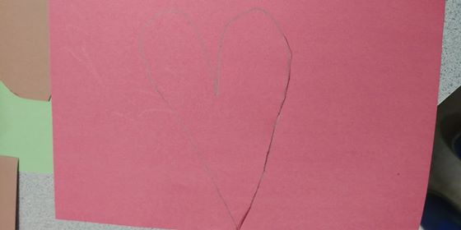
We all have many different types of hearts, whether it be evil or good. We all have something unique about each other. In this case the unique comes from within.
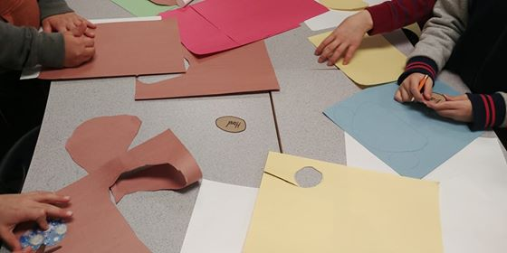
We all come from different backgrounds, whether it be race or upbringings we are all different in our own way. These students choose different colours to show individuality for their bears.
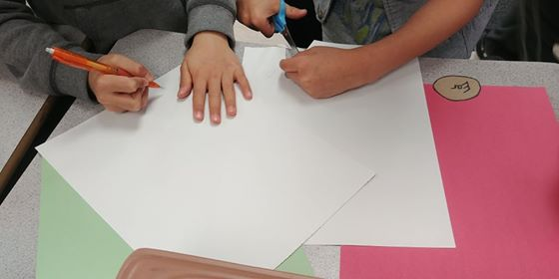
In many ways, we can show compassion; be it gifts, acts of kindness, or as simple as this, making a card. We encourage our younger generations to show love and admiration for special people in their lives, and that little acts of kindness can have big differences. With each stroke of a pencil, or each cut with scissors, these kids put their heart and soul into their cards, and we believe that’s where our compassion cards will display the most love towards others.

