Compassion Project Reflections

A’s Reflection:

For our project, my partner and I decided to write kind messages and put them in plastic Easter eggs to give to Norquay elementary. The purpose of our project was to help boost the self-esteem of elementary school students, while also developing strong relationships between high school and elementary school students. We decided to involve Windermere’s community by going around the hallways and getting staff and students to write some messages as well. We posted to social media on our stories, and managed to get some messages from other people digitally. After designing all the eggs and collecting messages, we emailed Norquay’s principal, Mr. Krug, and got his permission to run our project at Norquay.

While our project was successful, we did encounter some challenges along the way. I think that most of our challenges came from trying to market our project and collect messages in the school. The only people who were mainly willing to help us without question were the Leadership students. It was difficult to get non-Leadership students to write messages because they didn’t really see the point and did not want to get involved. We also posted on our Instagram stories, describing and promoting our project, which resulted in more messages for the eggs. However, it was difficult to collect evidence because people did not want us taking photos of them, and we couldn’t take photos of the Norquay kids with the eggs. I think something we could’ve done to improve our marketing would be to perhaps document our project more on social media, and giving consistent updates and posts as we put our project into action. This could have made people more aware of what we were doing with our project, and perhaps they would have felt more inclined to participate.

At the same time, there were many things that we did to make our project successful, that could apply to future projects. One of the things that I felt we did was follow that plan that we outlined in our project proposal a while back. Although it was challenging to follow through with our plan, we managed to follow all of the steps and follow through with everything that we said we would do in our proposal, something I noticed I’m not usually good at. Another thing that I think we did well at was having a solid communication with Norquay’s principal about our project. We found it difficult to find a school to run our project at because Grenfell wasn’t responding to our previous email, so we sent one to all the schools in

the neighborhood and Norquay was the first to respond. Once we got a school, we really wanted to work hard to establish a strong connection with the school and updating them on all of our project details, such as, what we wanted to accomplish, the purpose of our project, pick up and drop off times. I found myself pushing past my comfort zone for this project because I am a shy person, and not very comfortable with communicating with strangers, so I felt as if this was a good challenge for me. I think we did really well with coming up with backup plans, while still managing to follow through with everything we said we would, and communicating with the principal and showing we were grateful.

Overall, our project ran pretty smoothly and was successful. According to the principal, the eggs were very popular and were gone “within minutes”. Even though we encountered some challenges along the way, my partner and I managed to pull through and come up with a backup plan for things that didn’t work out as well. There were still things that we could work on if we have future projects that we can take into consideration, such as marketing and documenting our project more frequently. In conclusion, we are very happy with how our project turned out, and it pushed me to follow through with the plan and step out of my comfort zone.

M’s Reflection:

For our compassion project, my partner and I wrote kind messages, and put them in uniquely designed plastic Easter eggs. The eggs with the kind messages were then given to Norquay elementary school students. Our objective was to promote positive well being of students and to strengthen the relationship between Windermere high school students and Norquay students. To involve students and staff from Windermere, we walked along the hallways and asked them to write notes of kindness. We also posted on social media, describing our project and encouraging students to participate, managing to get kind messages digitally. When all eggs were finished and decorated, with messages put in them, we then emailed Norquays principal, Mr. Krug. After a few days, we got a confirmation letter from Mr. Krug saying it would be a pleasure for us to run our project at Norquay.

Our project was a success, however, we did come across some challenges. One of our biggest challenges was actually deciding what our project would be. We had to make sure our timing was right, our project would run smoothly, and that it would be manageable. Over the years I have come to realize that it is easy to come up with an idea but very

difficult to actually follow through with the plan. With that in mind, we took several days to decide on a project that was challenging but manageable. After overcoming this barrier, we then proceed with our proposal, then later on with the plan. We emailed Grenfell wanting to hold our project at their school, but after days with no reply, my partner and I emailed all schools around our neighborhood, desperate for any kind of response. Luckily Norquay replied saying they wanted our project at their school. I’m really proud of my partner and I for not abandoning this project once we could not get the school we were hoping for and instead thought of a plan B. My partner and I also struggled with collecting messages from a variety of students from Windermere, especially non leadership students. Many student refused to write any kind of messages giving excuses, such as being too tired or lazy. After three days of running through the hallways and scrambling to get students to write messages, we finally reached our goal of collecting 120 messages. Collecting photographic evidence of the process of asking students and “interviewing” the norquay kids was difficult because we were not given consent to take pictures of them. Although many problems occurred, we were still able to pull through.

Despite the many problems that occurred throughout the process, there were many thing that went well. We were able to follow through with the plan almost exactly as planned, although it was challenging. We were also able to finish decorating the eggs and messages within the given time. Our communication between the principal was well done, creating no complications. In addition, our timing was quite perfect and ran smoothly. However, despite everything looking so perfect, we did encounter many problems and in many cases had to resort to plan B. I found communicating with people and designing the eggs quite easy. However, even though I may come off as a confident person, the biggest thing I struggled with personally was not being able to come through with the project. I often show a happy face, but when focusing on huge projects like this, I often get nervous about not succeeding. I am scared to be met with failure, but this project has really shined light on how it’s okay to fail because from this project, I learned that failing will only help you bounce back harder.

Overall, Our project was a success! We were met with positive responses from the students of Norquay as the principal describes our project as “popular” and “ gone within minutes.” Although we encountered some problems we were able to bounce back using a lot of plan B’s and proceeding with our plan. For future projects, I will definitely take into account for creating immediate plan B’s to save time. All in all, my partner and I are very happy with the success of our project.

Photos/Evidence of the Process:
-the students we asked outside of Leadership did not allow us to take pictures of them
-we were not allowed to take photos of the Norquay kids
-due to the fact that we were not allowed to take picture made it very difficult to collect evidence Egg decoration and message process:

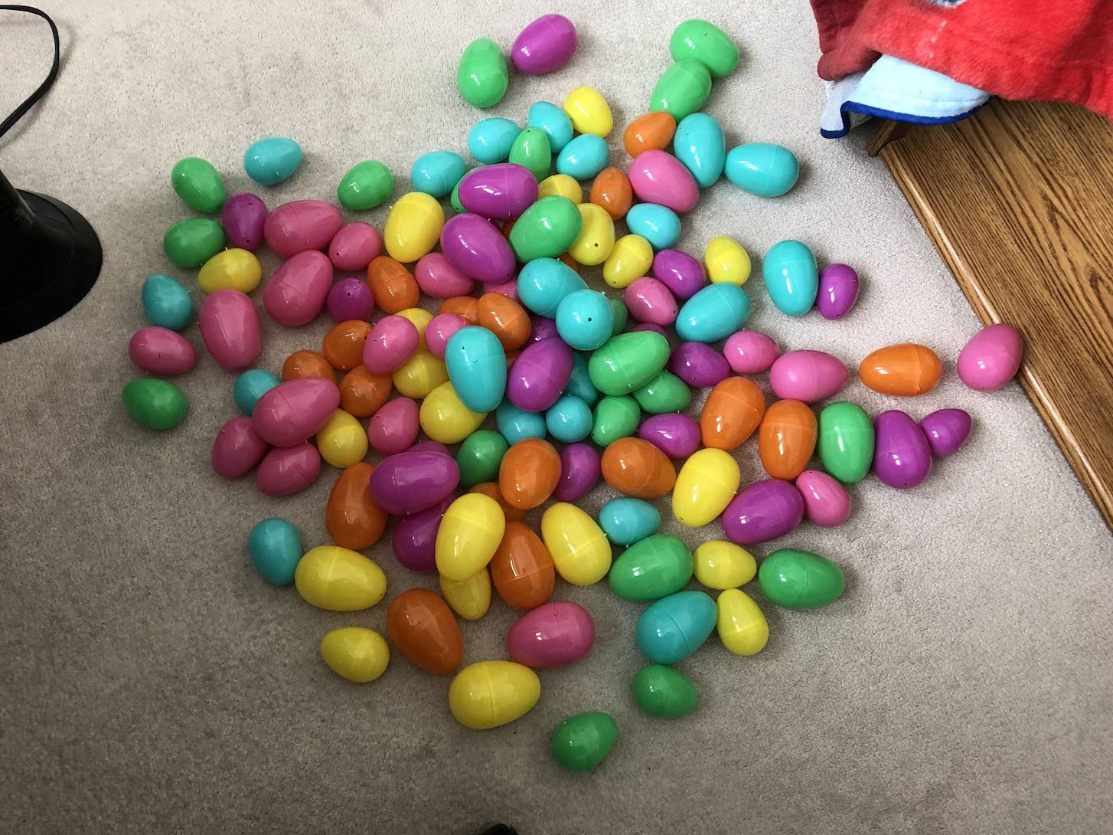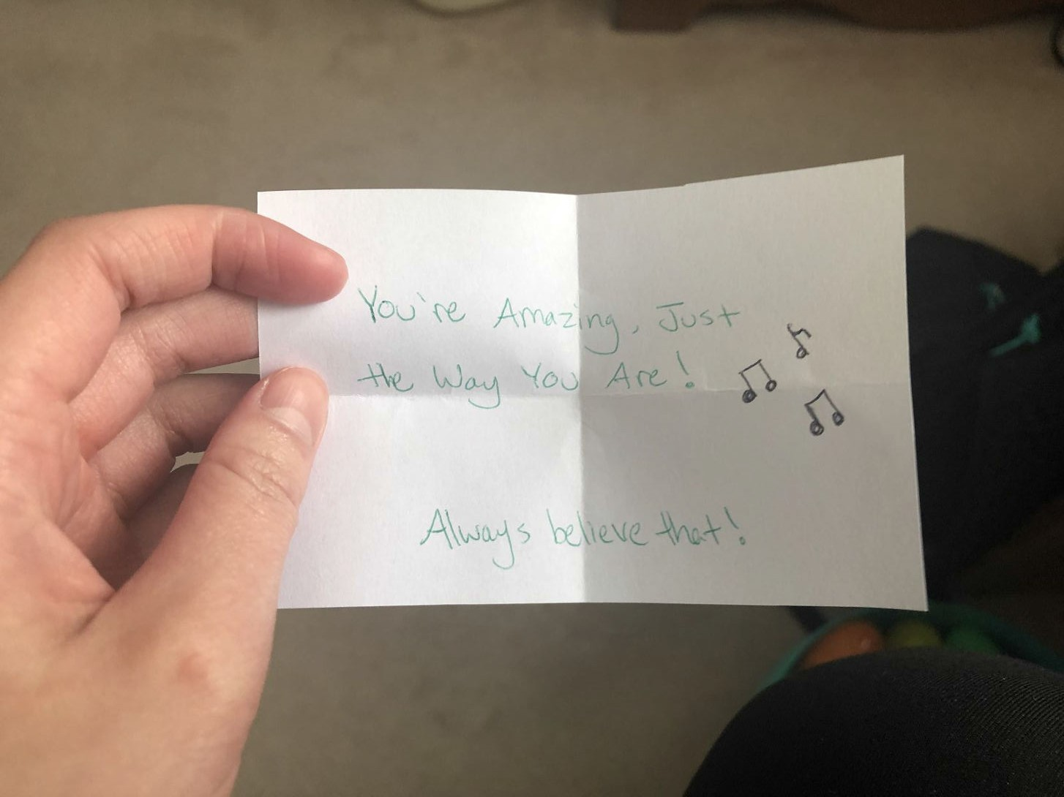

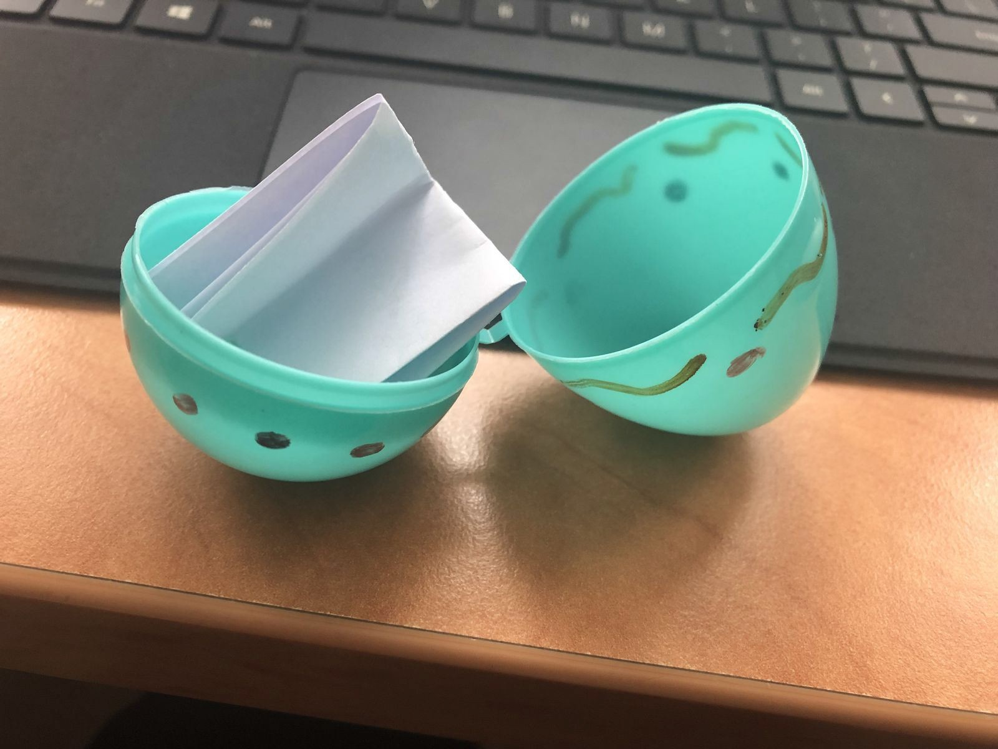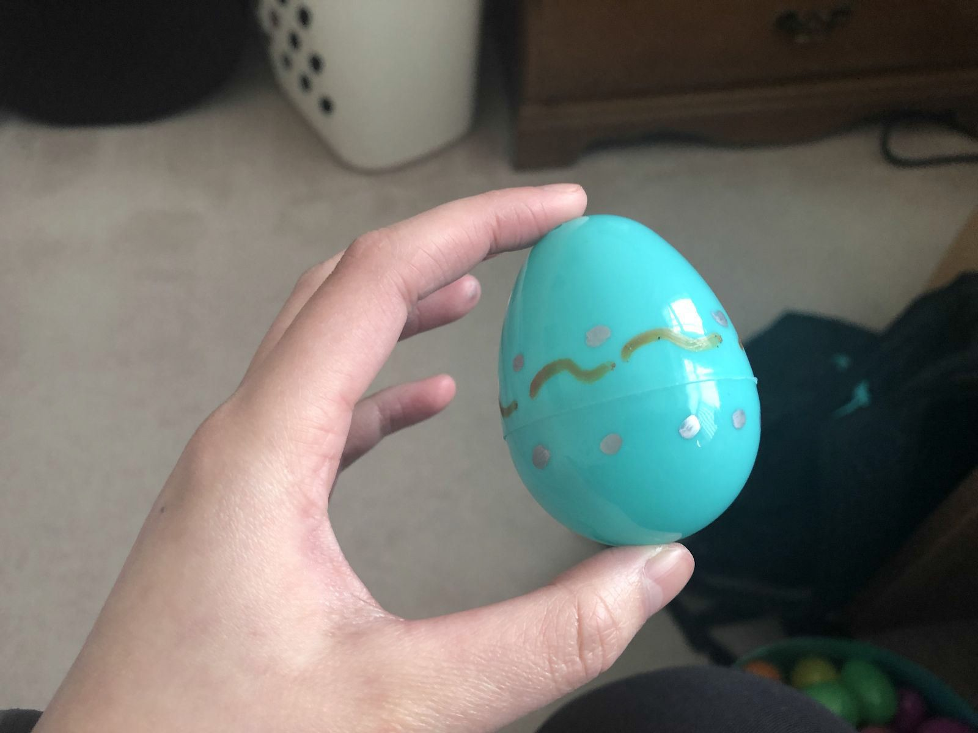

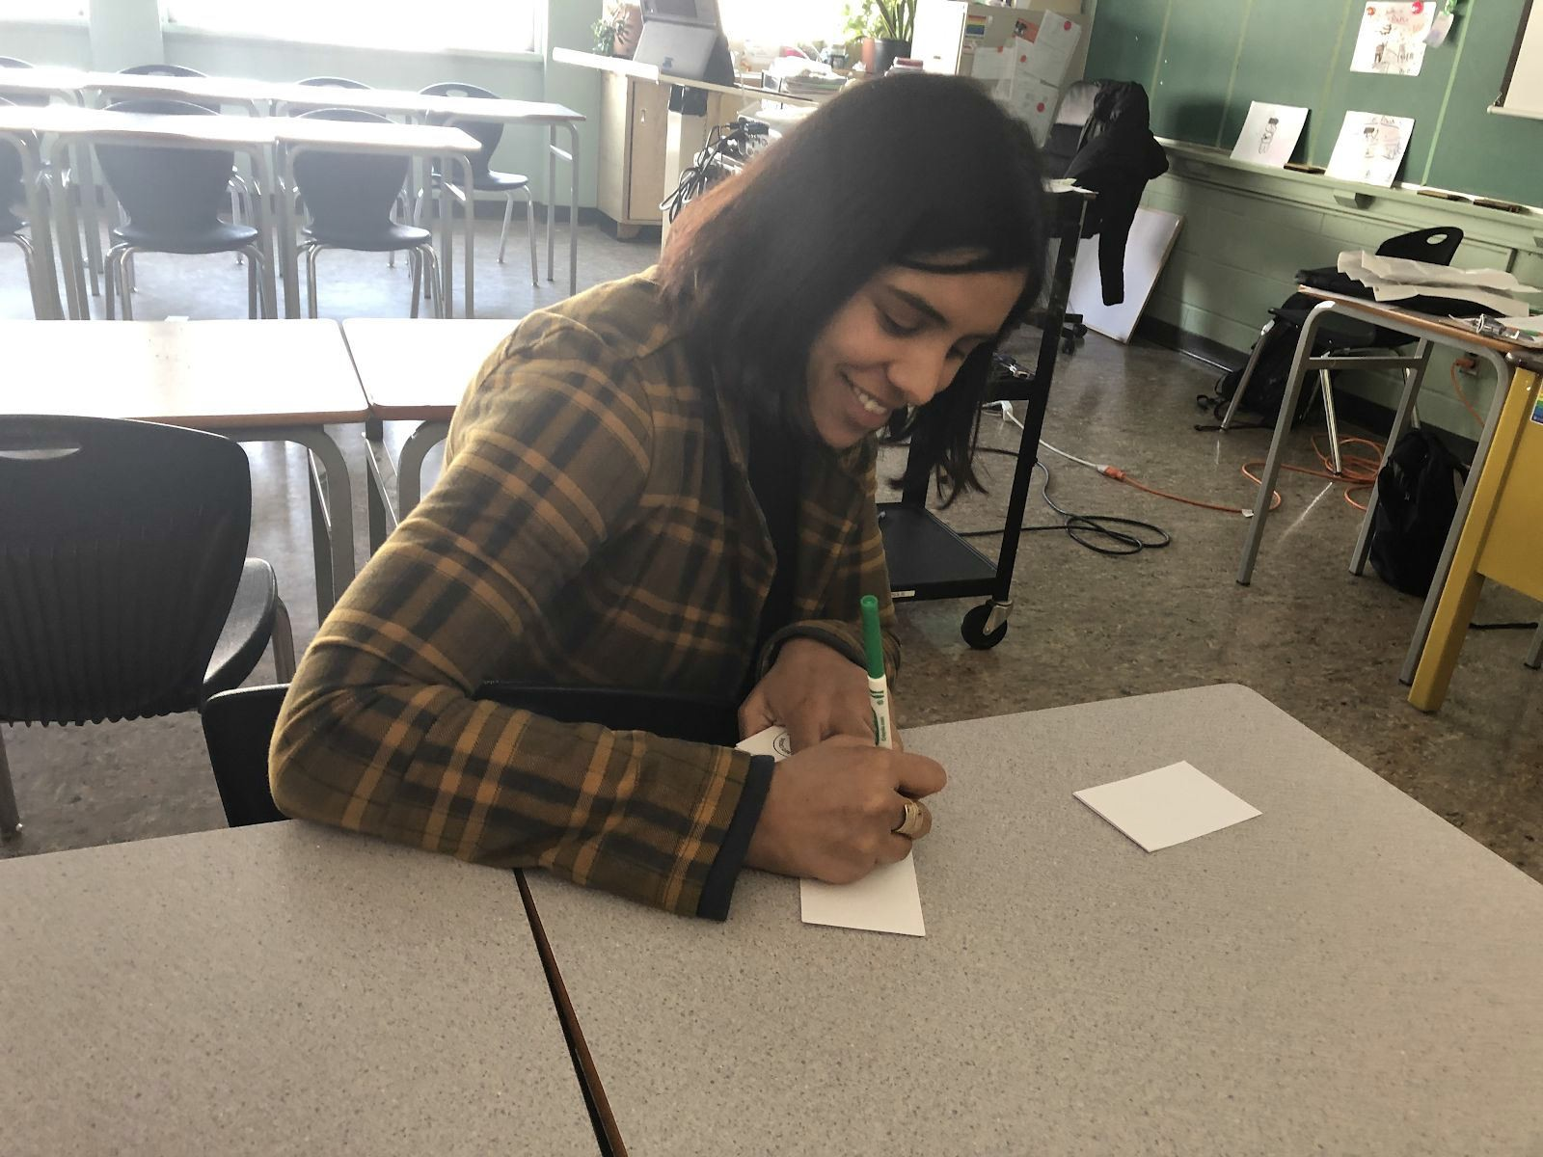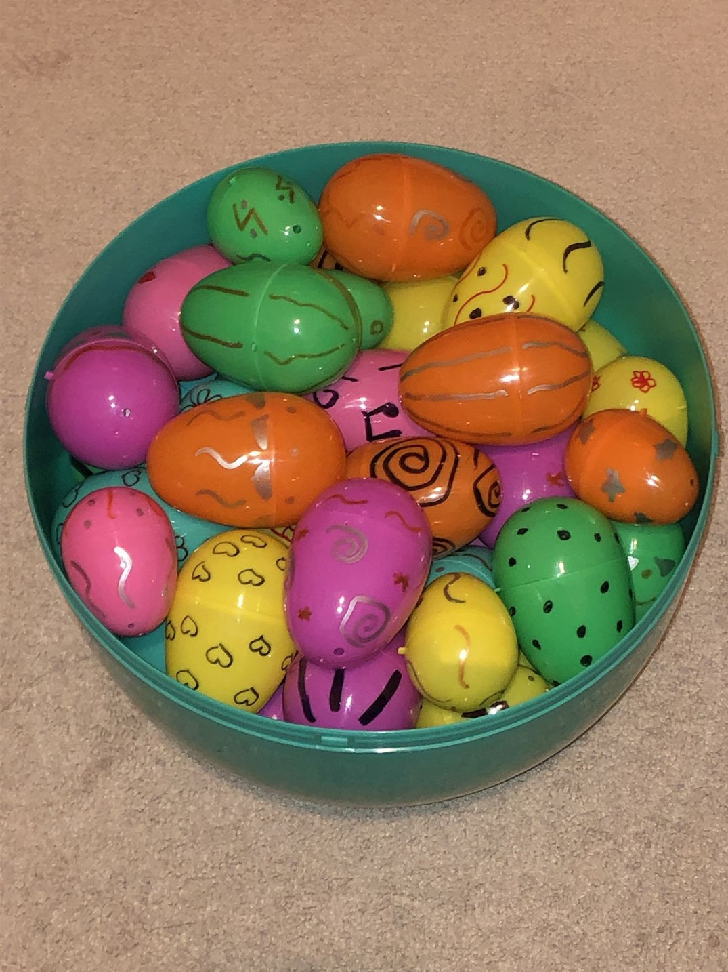

Digital messages:

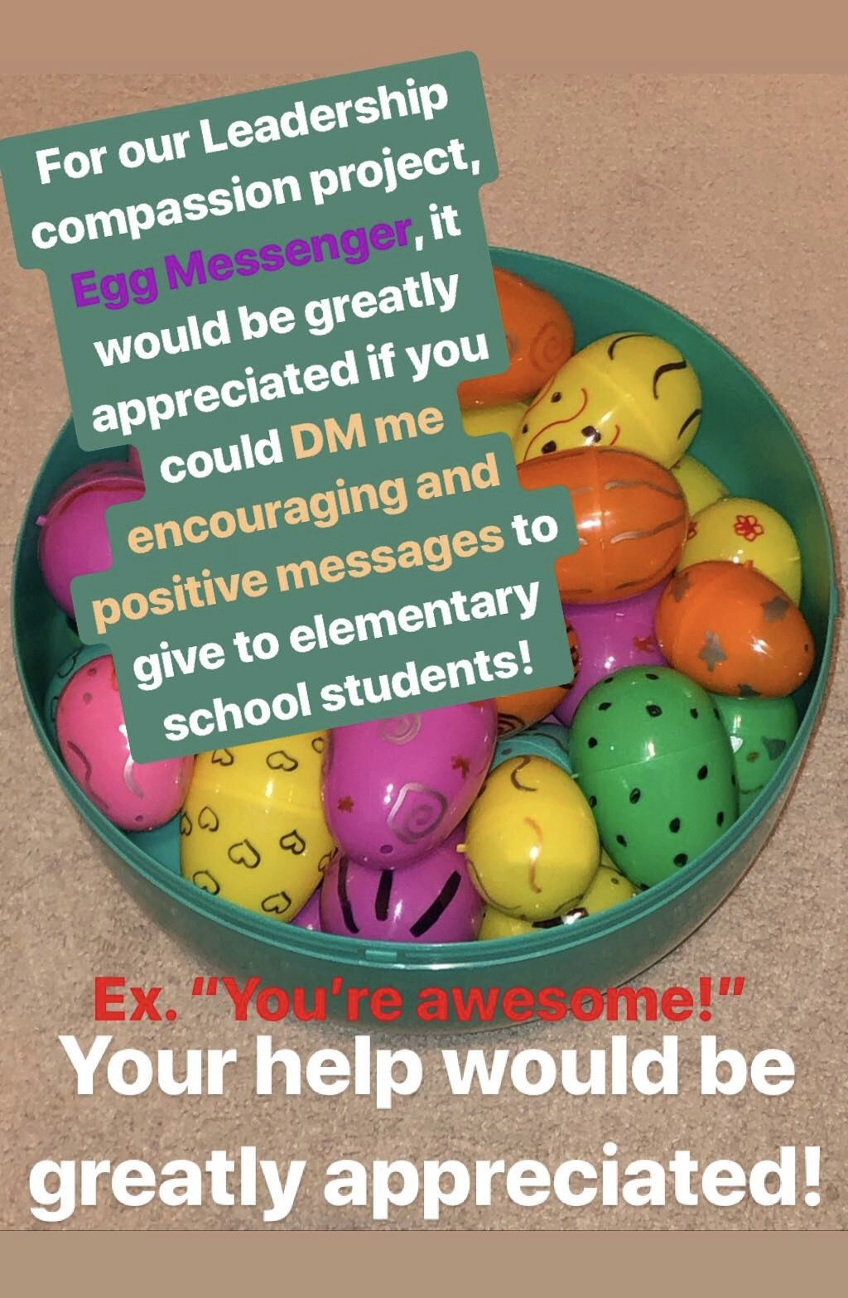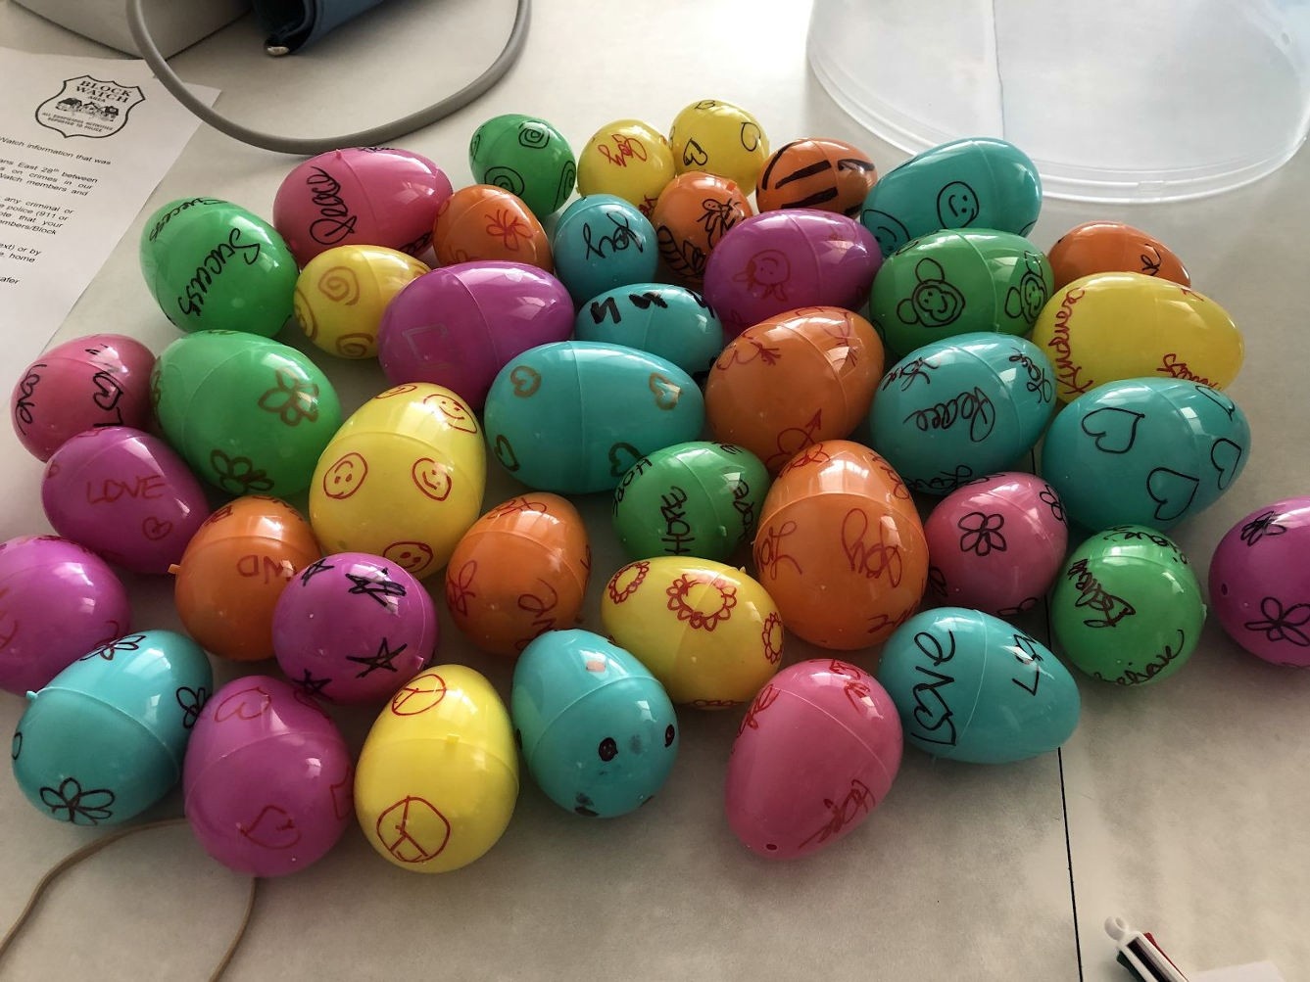

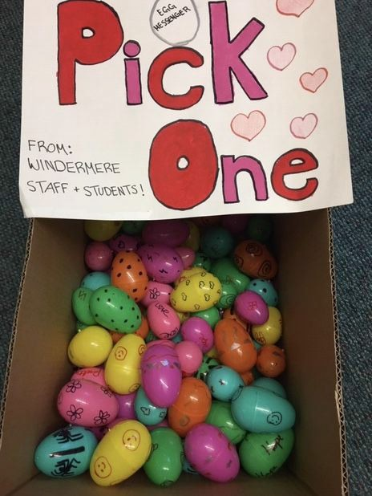

Project Completion Sheet (Logic Model)

Our project, Egg Messenger, is dedicated to promoting positive well-being of students, and to strengthen the relationships between high school and elementary students, specifically Windermere and Grenfell. We are students from Windermere Leadership who are passionate about helping our community and strengthening the bonds between younger students, because we understand the struggles they are going through, that’s why we want to lend a helping hand by giving them encouraging messages to show that we care. We also want to strengthen our connection with elementary school students. We have lots of experience with these kinds of projects through our time in the Leadership program, and my partner and I have worked together for many years, such as Student Council in elementary school, WCP, Safety Patrol, Library Monitor and many more because we have always had a passion for helping others. Egg Messenger is unique because we are not just trying to build relations within our school, but we are reaching out and trying to building relationships in our community. Even though these messages may not seem like a big deal, they are something that really puts a good effect on the students, showing our care and passion for others.

Outputs | Short-Term Outcome | Long-Term Outcome | Indicators | Data Collection Method
Compassion messages and positive well-being of the students | -boosting one’s  self-esteem for a day  -brighten up their day  -give them a sense of comfort and joy at that moment  -gives an element of surprise when they read the message | -these messages were created by Windermere students, and will not be easily forgotten  when they go through a hard time  -because of the hard work we spent on it, when they enter high school, they will feel a sense of security and support from others | -all of the eggs were gone when we picked up the box  -we managed to reach our goal 120 messages from Windermere staff and students  -the principal said that “all the eggs were all gone within minutes”  -according to the principal, many kids | -we did a small interview with the principal and a few Norquay kids, and got positive reviews back  -the principal said that “the students were very happy when they got an egg”  -one of the kids said that “the designs on the eggs were super cool!”

 |  | -the art and designs of the egg will perhaps be more memorable and remember the message in the future and feel comforted | participated and got an egg

