Rain Graffiti
Our idea is inspired by the students at UBC who created a fun activity to do on a miserable rainy day. They were able to create a rain activated art in which they displayed all over UBC in order to bring a bit of joy on a rainy day. Our project is WRG (Windermere’s Rain Graffiti), our goal is to bring silliness, creativity and fun on a typical Vancouver day. Whenever it starts to rain, the graffiti will appear from previously being invisible. This paint is eco-friendly and will eventually biodegrade and cause no harm to living things around the painted area. We will be setting up our displays around Windermere Secondary School, including the tennis court area and the entrance near the gym (on E 27th avenue and Windermere St). Maya and D(the organizers of this project) have an artistic background by being in many previous art classes and workshops. Our main goal is to paint flowers and spring/summer items to lift up students spirits and hopefully put a small but necessary positive impact on a gloomy Vancouver day.

How and who will your project impact?
Our project will impact the students and faculty of Windermere as well as the community around the school. It will impact them by putting a positive message in their head to brighten their day. For example, “You are awesome”. We really hope this will lift up people's spirits especially on a rainy Vancouver day.

How will you measure the success of your project?
We will observe students’ reactions throughout the month of February and half of March and see if they liked/disliked it. Also, we’ll ask students if they’ve seen the art outside and if so, then we will ask for feedback. Finally, we’ll check social media and see if it’s been shared or posted by students and community members. At the end we’ll gather our information and figure out if we were successful or not and see what we could improve on.

Timeline: February 7th - hand in proposal, February 11th rewrite proposal, February 13th- make samples and cut-outs for designs, test out product, talk to Ms. Kwon, February 16th-22th post to social media, February 27th-28th make final displays, March 1st-8th observe reactions of community/school members.

Project Goals Completion Summary
Outputs | Short-term Outcome | Long-term Outcome | Indicators | Data Collection Method
- Every rainy day in a week will be able to come and observe the art displays. | - Small impact - on someone just discovering the art  - Putting a smile on someone's face on a sad, rainy day.  - Time to appreciate the small things in life. | - Larger impact - that area could become a special place for someone to go to when feeling down.  - Able to inspire others. | - As we are painting the graffiti on the sidewalks a gym class walked by and told us that the things, we wrote were super nice which is what we were going for! | - When we go to observe the art display once a week, we will count the number of people we see at the art  - We sat outside for a bit looking at how many people looked down at the ground as they were walking/ running by.  - We counted 22 people in 8 minutes
- Social media awareness (posting on social media images of the art outside hoping to get the attention of Windermere students and community members, the posts and images will give positive messages out and give positive messages to their days) | - Positive impact from nice messages such as “You can do it!”, and creative drawing such as flowers or hearts, that can boost someone's creativity, and overall happiness towards more students at Windermere  - The artwork will draw people together from social media posts and bringing more attention to the artwork and maybe building new connections from people that you don’t know. | - The followers on social media of Windermere students might go to different schools and then spreading  awareness for our project.  - Brings the community together from going to our displays, building stronger or new relationships with people of Vancouver.  - Giving hope to people who are having a bad day and hopefully keeping a positive impact on them from seeing the art | - We documented the number of comments and shares on our personal Instagram posts  - We received 5 comments saying things like “wow this is so cool” and “where is this???” | - We counted the number of likes and comments we received on our posts and used that data to see how well we did.

M
March 2nd

Compassion Project Reflection
We did it! Despite the constant dumping of snow, my partner in crime, D and I managed to complete our rain graffiti. I’ve always loved the arts. From acting to painting to dancing, it’s always been something I’ve been drawn to, like a moth being attracted to a beam of light. When I found out we were given the freedom for the Compassion Project, my mind instantly went to arts. We had so many ideas, almost too many. We had so many ideas but none of them seemed hard enough or up to the standards of what was “outside of the box”. Then our teacher, Brendan, suggested that we could take on the idea of rain graffiti. I thought it was an amazing idea. It seemed super cool and very fitting considering the Vancouver weather. It rains at least once a week! D and I were set and ready to do. The ideas of what we could do were flowing through our brains faster than what we could write them down. We decided to write positive messages around the school to brighten someone’s day, on a rainy day. We also thought we could paint some positive words along the running route for gym class to keep people going and not to stop. Then the process of creating our project began.

D and I created all our stencils and were ready to go! We first needed permission from Ms. Kwon. We first went in to talk to her, she was busy, the second time, she was busy again. We tried to go see her at lunch, she was busy, at break, before and after school, but she was busy. After two weeks of going into the office to see if she was available, we finally found a time she was free. We got approved and we stared painting Prior to this, we couldn’t start yet because of the snow. We thought it would go away but it just stuck and didn’t move. We were so disappointed because we had to readjust our entire timeline. It wasn’t until February 27th-March 1st that we actually got to paint and see the results.
The results were great! We were really happy with how everything turned out and really hope that it can hep brighten peoples spirits up!

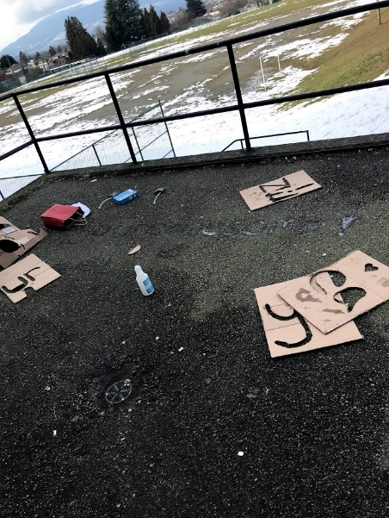  Work in progress. | 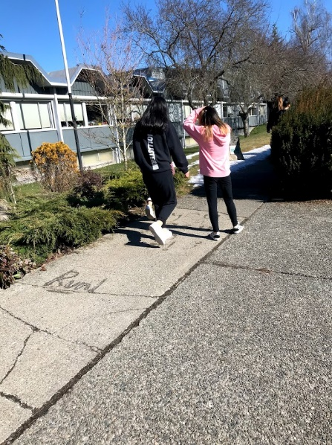  Windermere’s students noticing our rain graffiti and smiling (faces didn’t want to be shown so we took the photo from behind) | 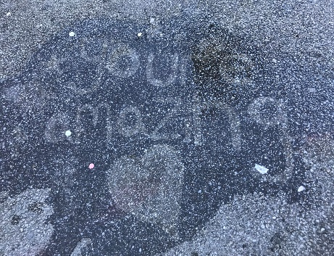Final product!

